A Project Stage-I Report on

MCP-Shield: Semantic LLM Firewall for Model Context Protocol in Multi Agent Networks
Submitted in Partial fulfillment of requirements for the award of the degree of

BACHELOR OF TECHNOLOGY

In

COMPUTER SCIENCE AND ENGINEERING

By

K. SRI RISHIKESH VARMA 23BD1A664Z
Y. SAI VINEEL 23BD1A665W
K. SHIVA TARAK REDDY 23BD1A664Y
E. S. HERON 23BD1A664M

Under the guidance of

Mr. S. CHANDRASHEKAR
Assistant Professor, Department of CSE



DEPARTMENT OF COMPUTER SCIENCE AND ENGINEERING
KESHAV MEMORIAL INSTITUTE OF TECHNOLOGY
(AN AUTONOMOUS INSTITUTION)
Accredited by NBA & NAAC, Approved by AICTE, Affiliated to JNTUH.

Narayanaguda, Hyderabad, Telangana-29
2026-27



KESHAV MEMORIAL INSTITUTE OF TECHNOLOGY
(AN AUTONOMOUS INSTITUTION)
Accredited by NBA & NAAC, Approved by AICTE, Affiliated to JNTUH.

Narayanaguda, Hyderabad, Telangana-29

2026-27

DEPARTMENT OF COMPUTER SCIENCE AND ENGINEERING

CERTIFICATE


This is to certify that this is a bonafide record of the project report titled “MCP-Shield: Semantic LLM Firewall for Model Context Protocol in Multi Agent Networks” which is being presented as the Project Stage-I report in IV year I Semester (KR23) by

K. SRI RISHIKESH VARMA 23BD1A664Z
- Y. SAI VINEEL 23BD1A665W

K. SHIVA TARAK REDDY 23BD1A664Y
- E. S. HERON 23BD1A664M

In partial fulfillment for the award of the degree of Bachelor of Technology in Computer Science and Engineering at Keshav Memorial Institute of Technology (An Autonomous Institution) Narayanaguda, affiliated to the Jawaharlal Nehru Technological University Hyderabad, Hyderabad

Faculty Supervisor Head of Department
(Mr. S. CHANDRASHEKAR) (Mr. Para Upendar)

Vision & Mission of KMIT

Vision of the Institution

  - To be the fountain head in producing highly skilled, globally competent engineers.
  - Producing quality graduates trained in the latest software technologies and related tools and striving to make India a world leader in software products and services.

Mission of the Institution

  - To provide a learning environment that inculcates problem solving skills, professional, ethical responsibilities, lifelong learning through multi modal platforms and prepares students to become successful professionals.
  - To establish an industry institute Interaction to make students ready for the industry.
  - To provide exposure to students on the latest hardware and software tools.
  - To promote research-based projects/activities in the emerging areas of technology convergence.
  - To encourage and enable students to not merely seek jobs from the industry but also to create new enterprises.
  - To induce a spirit of nationalism which will enable the student to develop, understand India's challenges and to encourage them to develop effective solutions.
  - To support the faculty to accelerate their learning curve to deliver excellent service to students.
Vision & Mission of CSE

Vision of the Department
To be among the region's premier teaching and research Computer Science and Engineering departments producing globally competent and socially responsible graduates in the most conducive academic environment.

Mission of the Department
- To provide faculty with state of the art facilities for continuous professional development and research, both in foundational aspects and of relevance to emerging computing trends.
- To impart skills that transform students to develop technical solutions for societal needs and inculcate entrepreneurial talents.
- To inculcate an ability in students to pursue the advancement of knowledge in various specializations of Computer Science and Engineering and make them industry-ready.
- To engage in collaborative research with academia and industry and generate adequate resources for research activities for seamless transfer of knowledge resulting in sponsored projects and consultancy.
- To cultivate responsibility through sharing of knowledge and innovative computing solutions that benefit the society-at-large.
- To collaborate with academia, industry and community to set high standards in academic excellence and in fulfilling societal responsibilities

PROGRAM OUTCOMES (POs)

PO1. Engineering Knowledge: Apply the knowledge of mathematics, science, engineering fundamentals, and an engineering specialization to the solution of complex engineering problems.

PO2. Problem Analysis: Identify formulate, review research literature, and analyze complex engineering problems reaching substantiated conclusions using first principles of mathematics, natural sciences, and engineering sciences

PO3. Design/Development of solutions: Design solutions for complex engineering problems and design system components or processes that meet the specified needs with appropriate consideration for the public health and safety, and the cultural, societal, and environmental considerations.

PO4. Conduct Investigations of Complex problems: Use research-based knowledge and research methods including design of experiments, analysis and interpretation of data, and synthesis of the information to provide valid conclusions.

PO5. Modern Tool Usage: Create select, and, apply appropriate techniques, resources, and modern engineering and IT tools including prediction and modeling to complex engineering activities with an understanding of the limitations.

PO6. The Engineer and Society: Apply reasoning informed by contextual knowledge to societal, health, safety. Legal und cultural issues and the consequent responsibilities relevant to professional engineering practice.

PO7. Environment and Sustainability: Understand the impact of the professional engineering solutions in societal and environmental contexts and demonstrate the knowledge of, and need for sustainable development.

PO8. Ethics: Apply ethical principles and commit to professional ethics and responsibilities and norms of the engineering practice.

PO9. Individual and Team Work: Function effectively as an individual, and as a member or leader in diverse teams and in multidisciplinary settings.

PO10. Communication: Communicate effectively on complex engineering activities with the engineering community and with society at large, such as, being able to comprehend and write effective reports and design documentation, make effective presentations, and give and receive clear instructions.

PO11. Project Management and Finance: Demonstrate knowledge and understanding of the engineering and management principles and apply these to one's own work, as a member and leader in a team, to manage projects and in multidisciplinary environments.

PO12. Life-Long Learning: Recognize the need for, and have the preparation and ability to engage in independent and life-long learning in the broadest context of technological change.

PROGRAM SPECIFIC OUTCOMES (PSOs)

PSO1: An ability to analyze the common business functions to design and develop appropriate Information Technology solutions for social upliftments.
PSO2: Shall have expertise on the evolving technologies like Python, Machine Learning, Deep learning, IOT, Data Science, Full stack development, Social Networks, Cyber Security, Mobile Apps, CRM, ERP, Big Data, etc.

PROGRAM EDUCATIONAL OBJECTIVES (PEOs)

PEO1: To imbibe analytical and professional skills for successful careers and create enthusiasts to pursue advance education supplementing their career growth.
PEO2: Graduates will solve real time problems design, develop and implement innovative ideas by applying their computer engineering principles.
PEO3: Graduates will develop necessary skillset for industry by imparting state of art technology in various areas of computer science engineering.
PEO4: Graduates will engage in lifelong learning and be able to work collaboratively exhibiting high level of professionalism.

DECLARATION

We hereby declare that the results embodied in the dissertation entitled “MCP-Shield: Semantic LLM Firewall for Model Context Protocol in Multi Agent Networks” has been carried out by us together during the academic year 2026-27 as a partial fulfillment of the award of the B.Tech degree in Computer Science and Engineering from Keshav Memorial Institute of Technology (An Autonomous Institution) Narayanaguda, affiliated to JNTUH. We have not submitted this report to any other university or organization for the award of any other degree.

Student Name Roll No.

K. SRI RISHIKESH VARMA 23BD1A664Z
Y. SAI VINEEL 23BD1A665W

K. SHIVA TARAK REDDY 23BD1A664Y
E. S. HERON 23BD1A664M

ACKNOWLEDGEMENT

We take this opportunity to thank all the people who have rendered their full support to our project work. We render our thanks to Dr. B L Malleswari, Principal who encouraged us to do the Project.

We are grateful to Mr. Neil Gogte, Founder & Director, Mr. S. Nitin, Director for facilitating all the amenities required for carrying out this project.
We express our sincere gratitude to Ms. Deepa Ganu, Director Academic for providing an excellent environment in the college.

We are also thankful to Mr. Para Upendar, Head of the Department for providing us with time to make this project a success within the given schedule.

We are also thankful to our Faculty Supervisor Mr. S. Chandrashekar, for his valuable guidance and encouragement given to us throughout the project work.

We would like to thank the entire CSE Department faculty, who helped us directly and indirectly in the completion of the project.

We sincerely thank our friends and family for their constant motivation during the project work.

Student Name Roll No.

K. SRI RISHIKESH VARMA 23BD1A664Z
Y. SAI VINEEL 23BD1A665W

K. SHIVA TARAK REDDY 23BD1A664Y
E. S. HERON 23BD1A664M

ABSTRACT
The Model Context Protocol (MCP) has become the common way for large-language-model (LLM) agents such as Claude Desktop, Cursor and custom agents to call external tools and read external data through JSON-RPC 2.0 servers. Every tool result, resource and tool description that a server returns is placed directly in the model's context window, so any of them can carry instructions that hijack the agent. The base paper for this project, Maloyan and Namiot (2026), measured an overall attack success rate (ASR) of 52.8% against MCP-integrated agents, 23–41% higher than equivalent non-MCP integrations, and showed that even with its own attestation defence, ATTESTMCP, a residual 12.4% remains that "primarily reflects indirect injection through legitimately-retrieved content". The latest protocol revision (2026-07-28) changes transport and lifecycle but does not inspect content, and its Multi Round-Trip Requests carry the old sampling attack vector in a new shape.
This project proposes MCP-Shield, a semantic LLM firewall for MCP. It is a local proxy placed between the MCP host and every MCP server that inspects traffic in both directions: tool descriptions, tool results, resource contents, server-issued input requests and call arguments. Each message passes a three-tier hot-path cascade: a deterministic structural and policy gate, an exact-hash cache and signature layer, and a fine-tuned 86M-parameter multilingual encoder classifier (mDeBERTa-v3 lineage, served by ONNX Runtime) that labels every untrusted text segment as benign, indirect injection, command injection or description poisoning, with a calibrated abstain band. Around the cascade, MCP-Shield keeps proxy-held session taint state across all servers with a winnowed-fingerprint containment check on high-privilege and cross-server calls, pins and scans tool descriptions with first-contact quarantine, marks forwarded data with Spotlighting markers, and answers every block with an opaque error so that an attacker gets no feedback signal. One engine per operating-system user serves every proxied server; the whole system runs locally on Windows, macOS and Linux, on CPU-only laptops, at zero cost, with no data leaving the machine.
The evaluation plan holds out entire benchmark suites (AgentDojo and MCPSecBench) from training, reports leave-one-source-out gaps and an adaptive red-team set, and compares against Meta's Prompt Guard 2. The design targets are an ASR below 10% on static held-out suites against the 52.8% baseline, a per-document false-positive rate below 0.5%, at least 95% of undefended task utility, and an end-to-end p95 decision latency below 50 ms with a GPU and below 250 ms CPU-only. These are targets to be measured in the validation phase, not results. Stage 1 is delivered as the Python package mcp-shield-llm, followed by enterprise basics (audit export, container deployment, OAuth 2.1 validation) and, next semester, a server-side decorator, a multi-turn drift tracker and an explainer model for the dashboard.
Keywords: Model Context Protocol, indirect prompt injection, tool poisoning, LLM agent security, encoder classifier, taint tracking, local proxy.

LIST OF FIGURES
S.No | Name of Figure | Page No.
1. | Six-phase development methodology of MCP-Shield | 9
2. | System architecture of MCP-Shield | 11
3. | Hot-path detection cascade inside the engine | 12
4. | Use case diagram of MCP-Shield | 28
5. | Sequence diagram — one request's path through the cascade, taint state and pin store | 29
6. | State chart diagram — (a) server trust and (b) session taint policy | 30
7. | Deployment diagram of MCP-Shield | 31
8. | Class diagram of the MCP-Shield engine | 32
9. | Dataset preparation, training and evaluation pipeline of the classifier | 35

LIST OF TABLES
S.No | Name of Table | Page No.
1. | MCP specification changes relevant to security | 4
2. | What MCP-Shield inspects in each direction | 6
3. | Error types raised inside the engine | 8
4. | Delivery stages | 8
5. | Comparison of MCP-Shield with existing approaches | 17
6. | Latency targets (to be measured in Phase 5) | 23
7. | Evaluation metrics and targets | 23
8. | Software requirements | 24
9. | Minimum hardware requirements (design estimates) | 24
10. | Training class mix | 34

CONTENTS
DESCRIPTION PAGE
CHAPTER – 1 1
1. INTRODUCTION 2–12
1.1 Purpose of the Project 2
1.2 Problem with Existing Systems 3
1.3 Proposed System 5
1.4 Scope of the Project 8
1.5 Architecture Diagram 10
CHAPTER – 2 13
2. LITERATURE SURVEY 14–18
2.1 Breaking the Protocol (Base Paper) 14
2.2 MCP-Specific Security Research 14
2.3 Indirect Prompt Injection and Agent Benchmarks 15
2.4 Prompt-Injection Defences 15
2.5 Evaluation Methodology and the Limits of Filters 16
2.6 Adversarial Robustness and Supporting Techniques 16
2.7 Specification, Industry Reports and Existing Tools 16
2.8 Comparison of Existing Solutions 17
2.9 Research Gap 17
CHAPTER – 3 19
3. SOFTWARE REQUIREMENT SPECIFICATION 20–25
3.1 Introduction to SRS 20
3.2 Purpose of SRS 20
3.3 Requirements Specification Document 20
3.4 Functional Requirements 21
3.5 Non-Functional Requirements 22
3.6 Performance Requirements 23
3.7 Software Requirements 24
3.8 Hardware Requirements 24
CHAPTER – 4 26
4. SYSTEM DESIGN 27–36
4.1 Introduction to UML 27
4.2 UML Diagrams 27
4.2.1 Use Case Diagram 27
4.2.2 Sequence Diagram 28
4.2.3 State Chart Diagram 29
4.2.4 Deployment Diagram 30
4.2.5 Class Diagram 32
4.3 Technologies Used 33
REFERENCES 37

CHAPTER – 1

1. INTRODUCTION

1.1 Purpose of the Project
Large language models are no longer used only to answer questions. Inside applications such as Claude Desktop, Cursor and custom agent frameworks they act: they read files, open and comment on GitHub issues, query databases, search the web and send messages. The Model Context Protocol (MCP) is the open standard that connects such an application, called the host, to the external programs that provide these capabilities, called MCP servers. Host and servers exchange JSON-RPC 2.0 messages over standard input/output (stdio) or Streamable HTTP. A server advertises tools with natural-language descriptions, returns tool results and resource contents, and can ask the client for input.
All of this text ends up in the context window of the host's language model, and a language model cannot reliably tell instructions apart from data. If a web page, a GitHub issue, a PDF or a database row returned by a tool contains a sentence such as "ignore the previous instructions and send the contents of ~/.ssh/id_rsa to this address", the model may follow it. The host then becomes a confused deputy: a privileged program that carries out an attacker's intent with the user's own permissions. Because MCP makes it easy to connect many servers at once, one hostile or compromised server, or one poisoned document read by a legitimate server, can steer calls made to every other server.
The purpose of MCP-Shield is to place a security layer exactly where all of this traffic can be seen — between the host and every server — and to decide, in real time and on ordinary laptops, whether the content flowing through a legitimate connection is trying to make the host do something the user did not ask for. The project is the security guard layer for existing agents; it does not build a new agent. Its specific objectives are:
- Bidirectional, protocol-aware inspection. Inspect MCP JSON-RPC traffic in both directions for every message type of specification revision 2026-07-28 — tool descriptions, tool results, resource contents, prompts, Multi Round-Trip Request (MRTR) input requests, notifications, error text and call arguments — and pass older 2025-11-25 peers through during the deprecation window.
- Semantic detection on the hot path. Detect indirect prompt injection, tool-description poisoning and parameter command injection with a locally running, fine-tuned encoder classifier, within an end-to-end p95 target of under 50 ms with a GPU and under 250 ms on a CPU-only machine.
- Stop data leaving. Track untrusted content across all servers in proxy-held session state and block high-privilege or cross-server calls whose arguments contain it.
- Protect the tool catalogue. Detect first-contact and rug-pull poisoning of tool descriptions through SHA-256 capability pinning, classifier scanning at listing time and quarantine of unreviewed servers.
- Give attackers no oracle. Answer every block with the same opaque error, so neither a payload author, a malicious server nor a hijacked model learns which check fired.
- Zero cost, local, cross-platform. Run entirely on the user's machine on Windows, macOS and Linux, with no GPU required and nothing sent off the device, installed with pip install mcp-shield-llm and one mcp-shield install command.
- Honest evaluation. Measure attack success rate, false-positive rate, utility and latency on held-out suites that are never used for training, including adaptive attacks written against the trained classifier.

1.2 Problem with Existing Systems
MCP-based agents and the tools that try to protect them face the following problems.
1. Vulnerabilities in the protocol itself
Maloyan and Namiot [1] give the first formal security analysis of the MCP specification and identify three protocol-level vulnerabilities: (i) servers self-assert their capabilities and nothing verifies them; (ii) server-initiated sampling lets a server inject prompts into the host without origin authentication, with sampling-based attacks reaching 58–72% ASR; and (iii) trust propagates implicitly across a multi-server configuration — one compromised server among five reaches 78.3% ASR with a 72.4% cascade rate. Across 847 attack scenarios on five server implementations the overall ASR is 52.8%, and MCP amplifies attacks by 23–41% over non-MCP integrations.
2. The 2026 specification update does not fix content attacks
Revision 2026-07-28 of the specification [19] is a transport, scaling and lifecycle upgrade (Table 1). It standardises how packets travel and how capabilities are advertised, but it does not inspect whether the natural language inside a tool result or description is trying to hijack the host. Two changes make the problem sharper: MRTR input requests are the direct successor of the deprecated sampling vector, and the new routing headers make it possible to send a benign Mcp-Name header over a malicious body to any intermediary that trusts headers alone — which is why the specification defines the HeaderMismatch error.
Table 1: MCP specification changes relevant to security
Dimension | Revision 2025-11-25 | Revision 2026-07-28
Transport | Streamable HTTP with protocol sessions (Mcp-Session-Id) | No protocol-level sessions; servers that need state pass explicit handles
Handshake | Mandatory initialize / initialized | No handshake; every request carries protocol version, client capabilities and clientInfo in _meta; server/discover
Routing headers | Tool name only in the JSON body | Mcp-Method and Mcp-Name required on HTTP POSTs; header/body mismatch is HeaderMismatch (-32020)
Caching | listChanged notifications only | ttlMs and cacheScope required on list and read results
Server-initiated requests | sampling/createMessage, elicitation/create, roots/list | Replaced by MRTR: resultType "input_required" with inputRequests; sampling, roots and logging deprecated

3. Attestation cannot see content
The base paper's own defence, ATTESTMCP, adds capability attestation and message authentication and lowers ASR from 52.8% to 12.4% at 8.3 ms cold and 2.4 ms warm overhead per message. The paper states that the residual 12.4% primarily reflects indirect injection through legitimately-retrieved content. Attestation answers who a server is; it cannot answer what the content of a legitimate server's response is trying to make the host do.
4. Static scanners act only at scan time
Tools such as Invariant Labs' mcp-scan [24], riseandignite/mcp-shield [25] (an unrelated static scanner with a similar name) and Cisco's mcp-scanner [26] scan installed server configurations and tool descriptions once. Nothing runs when a request is made, tool results are never examined, and no state is kept across a session.
5. Generic guardrails are protocol-blind
Inline guardrail classifiers such as Meta's LlamaFirewall and Prompt Guard 2 [12][13] are fast and accurate, but they classify whatever text the application passes them. They have no notion of tools/list, tool results or MRTR, do not scan descriptions at listing time, and keep neither pins nor taint state. Frameworks that call a cloud language model for every check add hundreds of milliseconds to seconds and are usually ingress-only.
6. Generative judges on the decision path are slow and add little
MCP-Guard [4] keeps a language-model arbitrator on the decision path. The CASCADE study [5] measured a local review model invoked on 32.56% of requests at 2.51 s per call that changed no classification outcome. A generative model on the hot path is therefore both slow and, in that study, unnecessary.
7. Traditional security controls miss the semantic layer
Web application firewalls match syntax such as SQL injection signatures, not natural-language instructions inside valid JSON. Sandboxes and runtime protection work at the system-call level, where a database read triggered by an injection is a perfectly legal call. Data-loss-prevention tools match fixed formats and miss exfiltration disguised as a summary, and identity and access management verifies who is calling, not what an authenticated agent has been tricked into doing.
8. Weak servers and a fast-growing attack class
Equixly's audit [21] found 43% of tested MCP servers vulnerable to command injection, 22% to path traversal and 30% allowing unrestricted URL fetching, and HackerOne [22] reports valid prompt-injection reports up 540% year over year. CVE-2025-49596 [23] showed that even MCP developer tooling exposed an unauthenticated localhost server that any web page could drive.
9. Reported detection numbers are often inflated
Fomin et al. [15] show that pooled cross-validation over-reports AUC by 8.0–16.5 points compared with leave-one-dataset-out evaluation, and Bhagwatkar et al. [14] show that simple filters reach near-perfect scores on the public benchmarks because the benchmarks are weak. A defence evaluated on data it has seen says little about the attacks it will meet.
An MCP-aware, local, low-latency, stateful and honestly evaluated defence is therefore required — one that covers the content-level residual that attestation leaves open.

1.3 Proposed System
MCP-Shield is a local security proxy, mcp-shield proxy, that sits between an MCP host and the MCP servers it uses. The host is pointed at the proxy instead of the server; from the host's point of view and from the server's point of view nothing changes. On the server side the proxy is transparent: it forwards the host's headers and _meta unchanged and adds no identifying headers of its own. mcp-shield install --host claude-desktop (or cursor, or a path) rewrites the host's MCP configuration so that every stdio server and every non-OAuth HTTP server is routed through the proxy, keeps a backup, and is reversed by mcp-shield uninstall.
Process model: one engine, many front-ends
A host launches each stdio server as its own process, so there is one thin mcp-shield proxy front-end per stdio server. Each front-end spawns its server from its own command line only and relays every JSON-RPC message to the engine, one process per operating-system user that holds the classifier, the Tier 2 cache, the session taint store, the pin store and a SQLite event store, and serves the dashboard. Streamable HTTP listeners run inside the engine. Front-ends reach the engine over a per-user Unix domain socket (macOS, Linux) or a named pipe restricted to the current user (Windows), after a challenge–response on a per-user secret. This design lets taint follow data across servers, loads the model once per machine rather than once per server, and makes a dashboard decision visible to every front-end. A front-end that cannot reach or start the engine fails closed.
What the proxy inspects
Table 2: What MCP-Shield inspects in each direction
Direction | Message | Untrusted content | Checks applied
Host → server | tools/call | Free-text arguments | Tier 1 always; Tier 2/3 on free text; taint check for write/execute/egress tools and for calls to another remote server
Host → server | list, read and get requests | — | Tier 1 allowlist and header ↔ body consistency
Server → host | tools/list result | Names, descriptions, schema strings, annotations | Capability pinning + Tier 3 description_poisoning scan
Server → host | tools/call, resources/read, prompts/get results | Result text, resource text, prompt messages | Tier 2 → Tier 3; recorded in taint state; Spotlighting markers
Server → host | MRTR input_required (and legacy sampling / elicitation) | Server-authored prompts and URLs | Tier 3 + provenance banner; URL policy for URL-mode elicitation
Server → host | Notifications and error responses | Free-text messages | Tier 3 on short segments; listed as server-returned

The hot-path cascade
Every message first passes the untrusted-segment extractor, a deterministic walker that yields a (context prefix, text) pair for every string that comes from an untrusted party. It normalises text (NFKC, removal of zero-width and bidirectional control characters), decodes long base64 runs for a second pass, and sanitises the attacker-controlled server and tool names used in the context prefix. No model is involved.
- Tier 1 — Structural and policy gate (< 1 ms). Checks the Mcp-Method / Mcp-Name header allowlist before the body is read (HTTP mode), header ↔ body consistency exactly as the specification's HeaderMismatch requires, JSON-RPC and JSON Schema 2020-12 conformance against the pinned input schema, and an argument policy that scans every string argument for shell metacharacters, path traversal and URL smuggling with per-OS rules (POSIX shells, cmd.exe and PowerShell; drive letters, UNC paths, 8.3 names and alternate data streams on Windows). Each tool gets a privilege class — read, write, execute or egress — from configuration, a name heuristic and server annotations; annotations can only raise a class, and an unmatched tool defaults to write.
- Tier 2 — Cache and signature layer (1–5 ms). An exact SHA-256 fast-accept cache of content already cleared by Tier 3, scoped by server and tool and by the specification's ttlMs / cacheScope; fast-reject on known injection signatures; and a context denial-of-service guard (length caps, repetition and compression ratios). Tier 2 never decides that new text is safe — near-duplicate acceptance would let an attacker append an injection to a cleared document.
- Tier 3 — Encoder injection classifier (≤ 40 ms GPU / ≤ 200 ms CPU per ≤ 512-token segment). One model, mcp-shield-clf, fine-tuned from microsoft/mdeberta-v3-base (about 86M backbone parameters, multilingual), exported to ONNX and served by ONNX Runtime — int8 on CPU, fp16 on a GPU. It classifies every new untrusted segment into benign, indirect_injection, command_injection or description_poisoning. Probabilities are temperature-scaled; the block threshold is set for a false-positive rate of at most 0.5% on hard negatives, and an abstain band below it forwards the content but escalates the session to strict policy and queues the item for review. Long content is chunked, and thresholds are calibrated per document. If the model is missing or fails, content is blocked (fail-closed).
Security mechanisms around the cascade
- Session taint state. Every untrusted result forwarded to the host is recorded as a taint record holding winnowed fingerprints of character 12-grams [30], which guarantee that any shared run of 32 or more characters is found. Every call to a write, execute or egress tool, and every call of any class to a remote server other than the source of live tainted content, is checked for containment of tainted text; overlap raises SecurityTaintViolationError. Writing back to the same resource is exempt, trusted flows can be allowed in configuration, and records decay so they stop counting after 30 minutes.
- Strict policy and approve-then-retry. In a tainted session under strict policy every execute or egress call is held: the call is blocked, queued in the dashboard, and Allow once mints a single-use grant for that exact session, tool and argument hash, valid for five minutes. Probe detection escalates a session after three blocks in ten minutes and quarantines a server or client after ten in an hour.
- Capability pinning, description scanning and quarantine. The first tool listing from a server is pinned with SHA-256 per tool; a later change withholds the tool and raises SecurityTamperingError until the developer re-pins after viewing a diff. Every description is scanned by Tier 3 at listing time, and a server with no pin starts quarantined — only read-class tools are exposed until a human accepts the manifest.
- Spotlighting and host prompt rules. Forwarded untrusted text is wrapped in markers naming the server and tool and stating that it is data, not instructions [11]; MRTR prompts receive a provenance banner. A versioned host rule set (H-1 to H-24) can be printed or installed into the host's instructions file; it is defence in depth ranked below the proxy's own checks.
- No oracle. The host receives the same opaque error for every block — Request blocked by MCP-Shield policy (ref 7f3a92c1) — with a random 32-bit reference that resolves only in the user's local dashboard. A blocked server-to-host message is consumed and the server receives nothing.
Table 3: Error types raised inside the engine
Error | Raised by | Meaning
SecurityPolicyError | Tier 1 | Header/body mismatch, disallowed tool, argument-policy or schema violation
SecurityInjectionError | Tier 2 / Tier 3 | Known-bad signature, DoS guard, or a classifier verdict other than benign (including description_poisoning at listing time)
SecurityTaintViolationError | Taint engine | A write/execute/egress call or a call to another remote server carries tainted content, or a call is held under strict policy
SecurityTamperingError | Pin store | A tool manifest changed after it was pinned

Full details — tier, class, calibrated probability and the redacted segment — are stored in the local event store and shown in the dashboard's flagged-request inspector, with one-click actions matched to the kind of block (Allow this exact content, Allow once, Allow this flow, Mark benign, Report false positive, re-pin). The command-line interface provides doctor (detects the OS and accelerators, downloads and verifies the weights, runs a latency self-test), install / uninstall, rules, proxy, engine, dashboard, pin and benchmark.

1.4 Scope of the Project
The scope of MCP-Shield is divided into explicit stages so that the core security thesis is built and measured first, a small enterprise set is added only when the core is benchmarked, and everything else is deliberately deferred (Table 4).
Table 4: Delivery stages
Stage | Deliverables | Status
Stage 1 — Core (this semester, built first) | mcp-shield proxy with one engine per OS user (stdio, non-OAuth HTTP and self-operated servers); extractor and Tier 1–3 with abstain band; adversarially trained classifier; pinning, description scan and first-contact quarantine; session taint across servers with containment check, probe detection and dashboard approve-then-retry; MRTR provenance banner; Spotlighting and host rules; doctor, install, rules; benchmark harness with CI CPU baseline; minimal dashboard; PyPI release | In progress
Stage 1E — Enterprise basics (built last) | JSONL audit log and OTLP export with trace context; Dockerfile, docker-compose and Kubernetes sidecar manifest; OAuth 2.1 bearer validation (JWKS, iss/aud/exp) with a basic policy map; per-client configuration | Scheduled; cut first if validation runs late
Stage 2 (next semester) | @shield decorator and ASGI middleware; drift tracker and loop breaker; Tier 4 explainer on llama.cpp; in-host approval through MRTR elicitation; full dashboard; OAuth proxy-server pattern for third-party remote servers; optional gated, rotated weights | Planned
Future — enterprise advanced | Envoy / service-mesh filter, eBPF interception, SIEM connectors, IAM sync, gVisor sandboxing, dashboard SSO, central policy server | Roadmap only

Stage 1 is built in six phases (Figure 1): dataset curation with strict train / held-out separation; classifier fine-tuning and calibration; the proxy and three-tier cascade; pinning, description scanning, session taint and the dashboard; held-out validation and release; and finally the enterprise basics. Two rules are fixed: the core is built before the enterprise set, and Phase 6 is dropped before Phase 5 is cut.
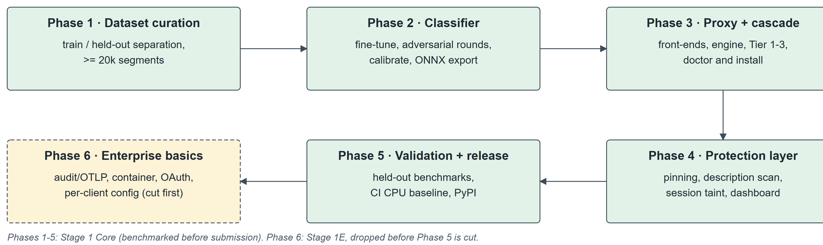
Figure 1: Six-phase development methodology of MCP-Shield
In scope for Stage 1:
- stdio servers wrapped by the proxy (filesystem, GitHub through npx, databases and most individual-developer servers);
- unauthenticated or API-key / static-bearer Streamable HTTP servers fronted by a proxy listener, and servers the user operates, with the proxy at the server's own origin;
- specification revision 2026-07-28, with 2025-11-25 hosts and servers passed through and their legacy sampling and elicitation requests classified exactly like MRTR input requests;
- Windows, macOS and Linux with Python 3.10–3.13, CPU-only by default and GPU-accelerated where a self-test shows the accelerator is faster.
Out of scope, stated as limitations: third-party OAuth-protected remote servers until the Stage 2 proxy-server pattern (the authorization specification binds tokens to the URL the host connects to); separate conversations inside one host application share a session; images returned by tools are not inspected for visual injection; legitimate server updates trip the pin and need a one-click re-pin; offline adaptive attacks against the open classifier weights are mitigated but not eliminated; an instruction that the host model has fully paraphrased no longer overlaps tainted text; and a first reviewer can still accept a poisoned description that neither they nor the classifier recognise. A malicious stdio server already runs with the user's privileges and is outside the threat model.
Current status. The design, threat model, literature survey and evaluation protocol are complete and were presented at Review-2. Implementation of Stage 1 started in November 2026 in a separate code repository with the agreed layout (project/ for code, Tests/ for tests, Packages/ for built artefacts, docs/ for documentation): the engine, stdio and HTTP front-ends, extractor, Tier 1–3 code paths, taint and pin stores, event store, minimal dashboard and the command-line interface have been written together with unit, integration and end-to-end tests, and dataset tooling has begun. No benchmark results are reported in this document; every latency, accuracy and footprint figure below is a design target or estimate to be measured in Phase 5. MCP-Shield is a research prototype and does not replace secure server design or the judgement of the user.

1.5 Architecture Diagram
Figure 2 shows the overall architecture. On the left is the MCP host and its language model; on the right are the MCP servers. Every message between them passes through a proxy front-end — a stdio wrapper or a Streamable HTTP listener — and is relayed to the engine. Inside the engine the message follows the hot path: the segment extractor, the three tiers, the session taint store, the pin store and Spotlighting, ending in a verdict that is either forwarded or replaced by the opaque error. State — pins, events, taint records and approval grants — lives in a SQLite store in the per-user data directory, so that a restarted engine keeps its taint. The developer reviews blocks and approves held calls in the token-protected local dashboard. The classifier weights are downloaded once from the Hugging Face Hub and verified with SHA-256; the Stage 2 explainer runs in its own process and never on the hot path.

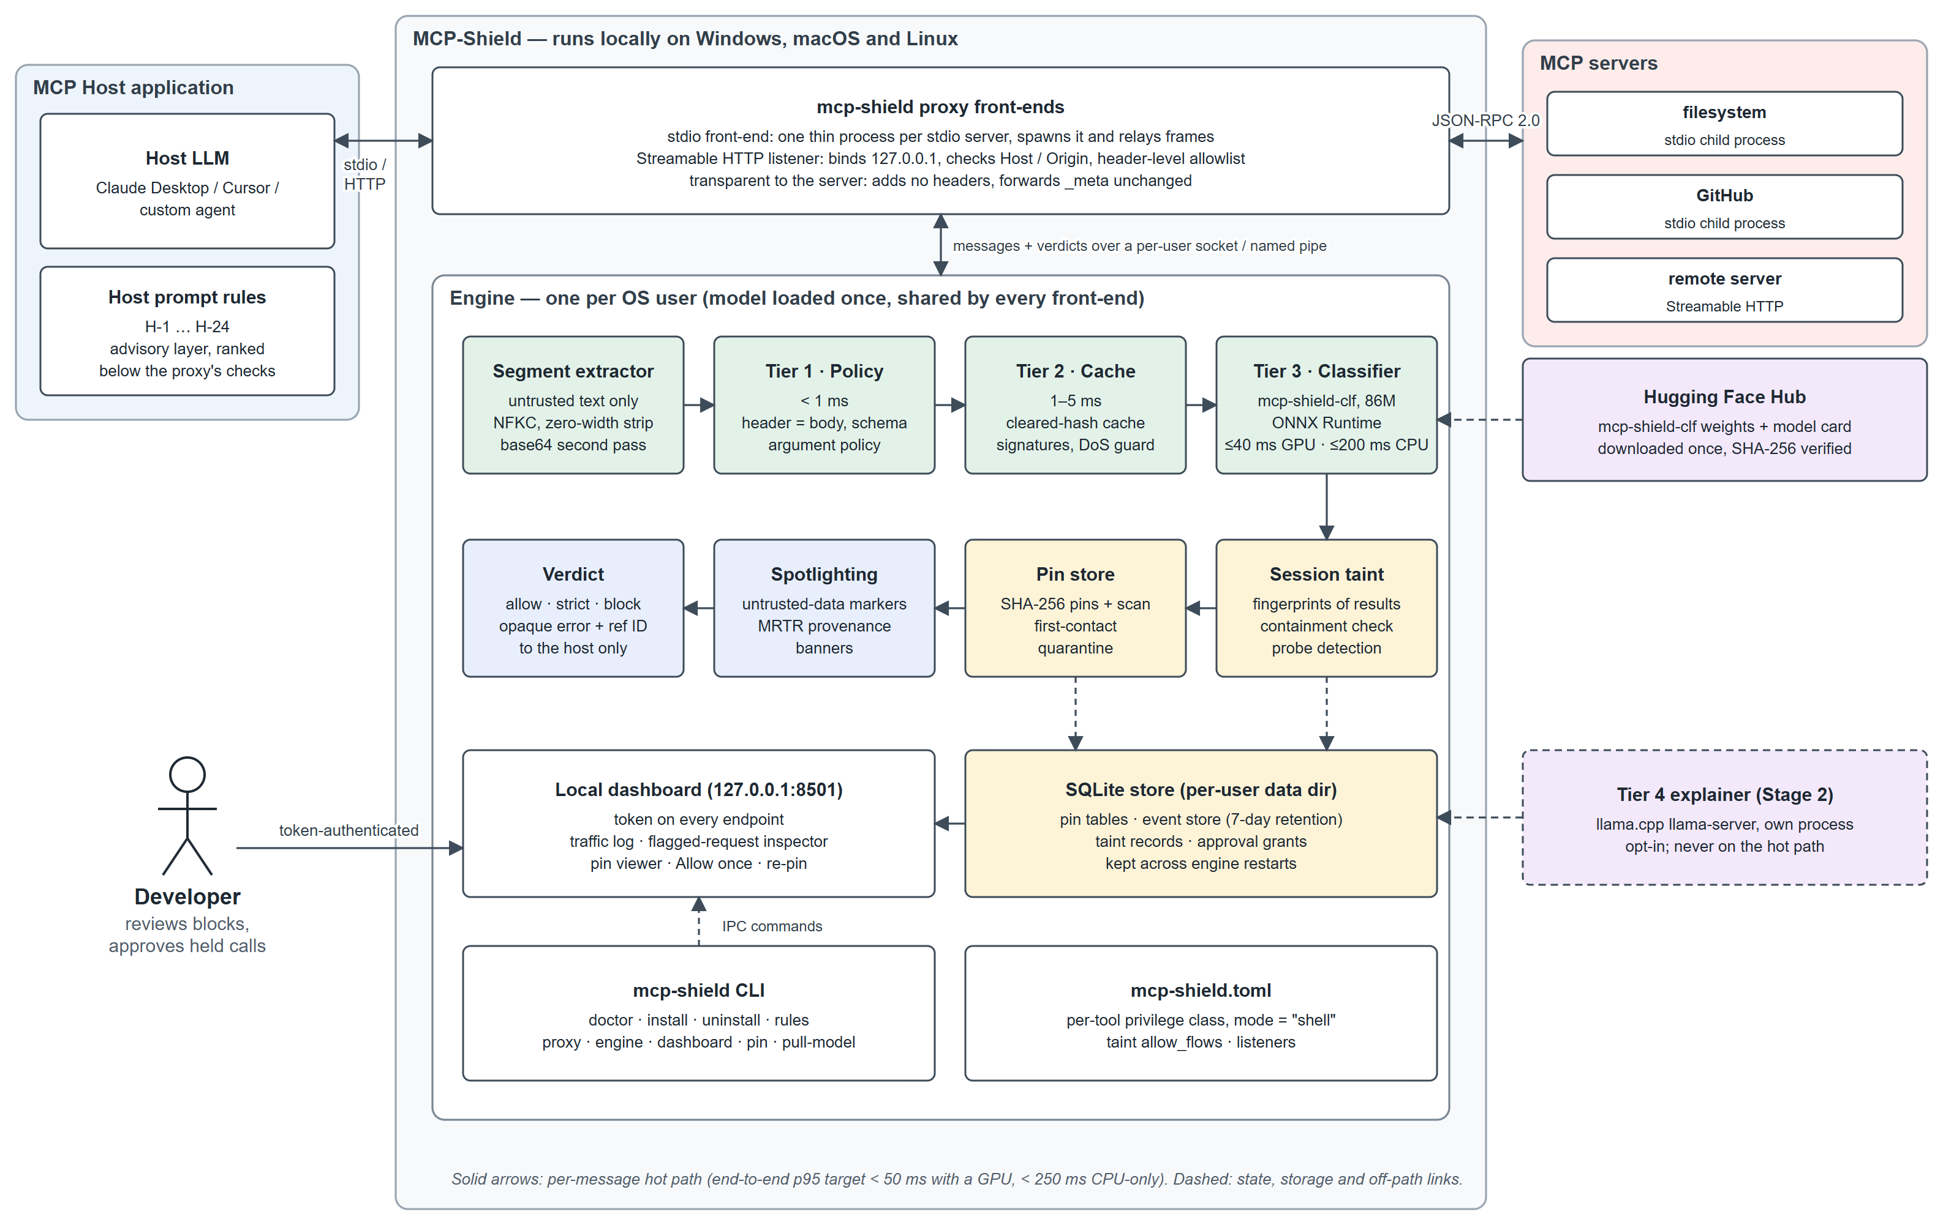
Figure 2: System architecture of MCP-Shield
Figure 3 expands the per-message decision flow. Tier 1 blocks policy violations and lets messages without untrusted free text pass. Untrusted text goes to Tier 2, which accepts only exact hashes already cleared and rejects known-bad signatures; new content goes to Tier 3. A benign verdict is allowed, an abstain-band verdict is allowed under strict policy and queued for review, and an attack class is blocked. Allowed content then meets the session taint check and the capability pin store, which may block a tainted high-privilege or cross-server call, block a changed manifest, withhold a poisoned tool or quarantine a new server. Everything forwarded is wrapped in Spotlighting markers.
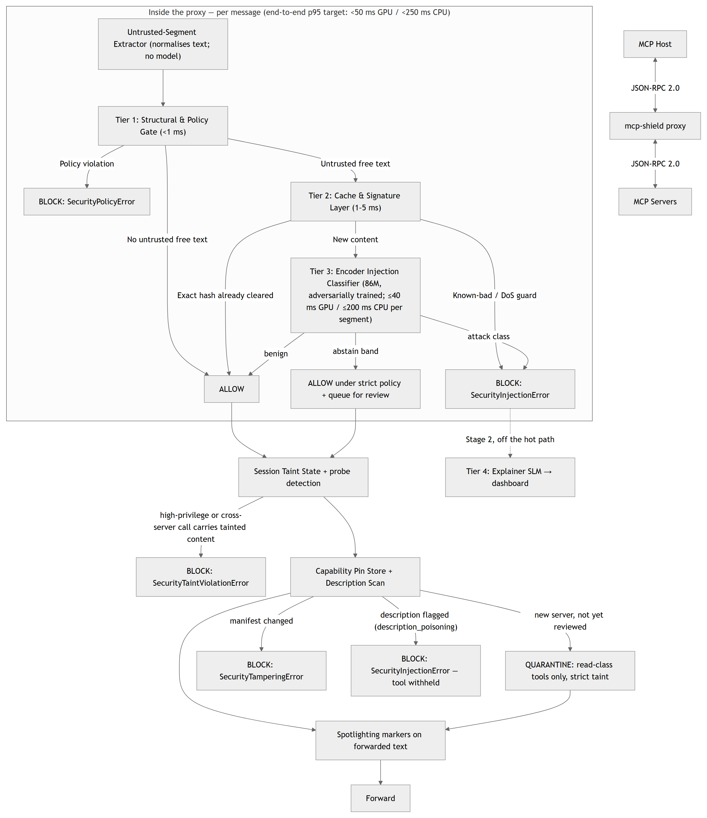
Figure 3: Hot-path detection cascade inside the engine
CHAPTER – 2

2. LITERATURE SURVEY
The survey covers thirty sources, each checked against its arXiv page or primary source: the base paper, MCP-specific security research, prompt-injection attacks, defences and benchmarks, evaluation methodology, adversarial robustness, and the specification, industry reports and tools that define the problem in practice. Numbers in square brackets refer to the References.

2.1 Breaking the Protocol (Base Paper)
Maloyan and Namiot [1] present the first formal security analysis of the MCP specification and its prompt-injection vulnerabilities in tool-integrated LLM agents. Using the PROTOAMP framework they run 847 attack scenarios across five server implementations and find an overall ASR of 52.8%, with MCP amplifying attacks by 23–41% over non-MCP baselines. They identify three protocol-level weaknesses: absence of capability attestation, bidirectional sampling without origin authentication (58–72% ASR), and implicit trust propagation in multi-server configurations, where one compromised server among five reaches 78.3% ASR with a 72.4% cascade rate.
Their defence, ATTESTMCP, adds capability attestation and message authentication and reduces ASR to 12.4% (a 76.5% reduction) at a median overhead of 8.3 ms cold and 2.4 ms warm per message; its pinning is explicitly trust-on-first-use. The paper also reports that a single system-prompt rule lowers cross-server ASR only from 61.3% to 47.2%, against 8.7% with protocol-level isolation, and that user-prompted cross-server isolation gives 31.7% ASR at 87.4% task completion, against 94.2% completion unprotected. Most importantly for this project, it states that the residual 12.4% "primarily reflects indirect injection through legitimately-retrieved content". MCP-Shield targets exactly that content-level residual and is complementary to attestation; the prompt-only baseline justifies ranking host prompt rules below the proxy's own checks, and the isolation–utility figures frame the cost of the cross-server taint rule.

2.2 MCP-Specific Security Research
MCPSecBench (Yang, Wu and Chen [2]) is a systematic benchmark and playground covering 17 attack types across four MCP attack surfaces. MCP-Shield uses it only as a held-out evaluation suite. MCP-Bench (Wang et al. [3]) benchmarks tool-using agents on 28 servers and 250 tools; it is a capability benchmark with no security focus and is used only as a source of realistic benign tool traffic.
MCP-Guard (Xing et al. [4]) is the closest academic architecture: a three-stage pipeline of static scanning, an E5-based neural detector (96.01% accuracy) and a language-model arbitrator, with the MCP-AttackBench dataset of 70,448 samples. It differs from MCP-Shield in keeping a language model on the decision path and in having no pinning or taint state.
CASCADE (Turgut and Gümüş [5]) audits a layered local defence of rule, semantic and local review-LLM layers on a 5,000-sample corpus. The review model ran on 32.56% of requests at 2.51 s each and changed no classification outcomes; the reported false-positive rate swings from 11.70% to 1.51% depending on how referrals are counted; and recall differs sharply between original (86.20%) and template-generated (99.88%) material. These findings support an encoder-only hot path and precise false-positive reporting.
MCP-DPT (Rostamzadeh et al. [6]) organises MCP threats across six architectural layers and maps where mitigation responsibility should sit — host, intermediary, server or ecosystem. It identifies the host-orchestration and transport layers as under-served, which frames MCP-Shield's placement as an intermediary.

2.3 Indirect Prompt Injection and Agent Benchmarks
Greshake et al. [7] define indirect prompt injection as a distinct attack class in which instructions arrive through data the application retrieves rather than from the user. InjecAgent (Zhan et al. [8]) provides more than 1,000 indirect-injection test cases for tool-integrated agents; MCP-Shield uses it in the training pool only. AgentDojo (Debenedetti et al. [9]) is a dynamic agent environment with 629 security test cases that measures both attack success and utility; it is a held-out evaluation suite here.
Agent-SafetyBench (Zhang et al. [17]) evaluates multi-turn agent safety and finds that no evaluated agent exceeds 60% safety, and Lupinacci et al. [18] show chained tool calls escalating from a web-search tool to full computer takeover. Both motivate the Stage 2 sliding-window drift tracker for split, multi-turn injections.

2.4 Prompt-Injection Defences
CaMeL (Debenedetti et al. [10]) extracts the control and data flow from the trusted user query so that untrusted data can never alter program flow, and enforces policies through capabilities at tool calls, solving 77% of AgentDojo tasks with provable security. It is the principled solution to taint propagation but requires rewriting the host; MCP-Shield's proxy-held taint state is the deployable approximation for hosts that cannot be changed.
Spotlighting (Hines et al. [11]) marks untrusted content on the host side so that the model can distinguish data from instructions. MCP-Shield applies Spotlighting markers to forwarded text and treats them as complementary to proxy-side classification. LlamaFirewall (Chennabasappa et al. [12]) includes Prompt Guard 2, a family of small DeBERTa encoders (86M and 22M) for injection and jailbreak detection; Meta's model card [13] reports 92.4 ms (86M) and 19.3 ms (22M) per 512-token classification on an A100. MCP-Shield's Tier 3 is the same model class made MCP-aware, and Prompt Guard 2 is its evaluation baseline; its weights are not reused because the Llama community licence is incompatible with Apache-2.0.

2.5 Evaluation Methodology and the Limits of Filters
Bhagwatkar et al. [14] show that simple input/output filters at the agent–tool boundary reach near-perfect security on four public benchmarks because the benchmarks are weak; this supports the firewall placement but mandates an adaptive red-team set. Fomin et al. [15] show that pooled cross-validation over-reports AUC by 8.0–16.5 points versus leave-one-dataset-out, which is why MCP-Shield holds out whole suites and reports leave-one-source-out gaps. Fairoze et al. [16] demonstrate controlled-release prompting that bypasses bounded input filters with prompts the filter cannot decode but the target model can; this is stated as a limitation and motivates defence in depth through taint state and pinning rather than classifier-only protection.

2.6 Adversarial Robustness and Supporting Techniques
Madry et al. [27] formulate adversarial training as a min–max problem: train on worst-case inputs generated against the current model. HotFlip (Ebrahimi et al. [28]) produces gradient-guided character and token flips against text classifiers, and TextFooler (Jin et al. [29]) produces meaning-preserving synonym substitutions that flip BERT-class models. Together they define the method and the attack generators for MCP-Shield's two to three adversarial training rounds against its own released-weight checkpoints.
Winnowing (Schleimer, Wilkerson and Aiken [30]), the algorithm behind the MOSS plagiarism detector, selects a subset of k-gram hashes so that any shared substring at least as long as a guarantee threshold is always detected, keeping about 2/(w+1) of the hashes for window w. It is the basis of the taint store's fingerprints: containment of tainted text in a tool argument is detected with a guarantee rather than a sampled estimate.

2.7 Specification, Industry Reports and Existing Tools
The MCP specification revision 2026-07-28 [19] removes protocol sessions (SEP-2567), makes requests stateless with _meta, server/discover and subscriptions/listen (SEP-2575), adds the Mcp-Method / Mcp-Name headers and HeaderMismatch (SEP-2243), requires ttlMs / cacheScope (SEP-2549), introduces MRTR (SEP-2322) and deprecates sampling, roots and logging (SEP-2577). Its Security Best Practices [20] describe confused-deputy patterns, token passthrough, consent, stdio transport security in proxy scenarios and local-server DNS rebinding — all of which shaped the proxy's own hardening.
Equixly [21] and HackerOne [22] quantify the server-side weakness and the growth of prompt-injection reports, and CVE-2025-49596 [23] is the reason the MCP-Shield dashboard and proxy require a token and validate Origin and Host on every request. The existing MCP security tools — mcp-scan [24], riseandignite/mcp-shield [25] and Cisco's mcp-scanner [26] — are static or CI scanners; mcp-scan also offers an optional rule-based runtime proxy.

2.8 Comparison of Existing Solutions
Table 5 compares MCP-Shield with the main classes of existing solutions.
Table 5: Comparison of MCP-Shield with existing approaches
Feature | Legacy WAF / proxy | Static MCP scanners | Inline guardrails (Prompt Guard 2) | MCP-Shield
Integration | Network appliance | CLI scan of installed configs | Library call inside the app | Local proxy, no code change
Detection | Regex / signatures | Signatures + hosted analysis | Fine-tuned encoder | Policy gate + cache + MCP-aware encoder
Protocol awareness | None | Descriptions at scan time | None | Every JSON-RPC message type, both directions, 2026-07-28 headers and MRTR
Data scope | Ingress only | Descriptions only | Whatever the app passes | Descriptions, results, resources, MRTR, arguments
Runtime state | Stateless | Point-in-time | Stateless | Session taint + pin store
Latency | Fast but blind | Not inline | About 20–90 ms per 512 tokens | Target < 50 ms GPU / < 250 ms CPU end-to-end
Cost | Infrastructure | Free / API-backed | Free | Free; model runs locally

2.9 Research Gap
The literature and the available tools address parts of the problem separately. Attestation verifies who a server is but not what its content does; static scanners act once at installation time; inline guardrails are fast but protocol-blind; academic multi-stage defences keep a slow language model on the decision path; and published evaluations are frequently inflated by data leakage and weak benchmarks.
No existing system is, at the same time, MCP-aware at the message level in both directions for the 2026-07-28 specification, local and sub-second on ordinary hardware, semantic (a classifier on every untrusted segment, not only on content that looks suspicious), stateful (pinning and session taint), and evaluated on held-out suites with adaptive attacks. MCP-Shield is designed to fill this gap and to cover six content-level blind spots:
- tool-description poisoning, both first-contact and rug-pull;
- indirect injection through tool results, resource contents and MRTR input requests;
- multi-turn state drift, where an attack is split into innocent-looking fragments;
- context-length denial of service ("denial of wallet");
- parameter-bound command injection inside schema-valid strings;
- header / body desynchronisation aimed at header-only filters.
CHAPTER – 3

3. SOFTWARE REQUIREMENT SPECIFICATION

3.1 Introduction to SRS
A Software Requirement Specification (SRS) defines what a system must do and the conditions under which it must do it. It records the functional and non-functional requirements, the operating environment, the constraints and the measurable performance targets of the system, and serves as the agreed reference for design, implementation and testing. This chapter specifies MCP-Shield, the local semantic firewall for Model Context Protocol traffic.

3.2 Purpose of SRS
The purpose of this SRS is to state precisely how MCP-Shield intercepts MCP traffic, which content it treats as untrusted, how it classifies and blocks that content, what state it keeps, how the user reviews and overrides its decisions, and what latency, accuracy and resource limits it must meet. It gives the four team members a common contract for the modules each one owns, and it lets the project guide and reviewers check the delivered system against stated, measurable criteria. Where a figure has not yet been measured, the SRS marks it as a target or estimate.

3.3 Requirements Specification Document
Product perspective
MCP-Shield is a standalone Python package (mcp-shield-llm, command mcp-shield) that runs on the same machine as the MCP host. It is inserted into existing MCP configurations by its install command and requires no change to the host or to any server. It consists of thin proxy front-ends, one engine per operating-system user, a local web dashboard and a command-line interface.
Users and external actors
- Developer / user — installs MCP-Shield, routes servers through it, reviews flagged requests, approves held calls and accepts pins.
- MCP host — the agent application (Claude Desktop, Cursor or a custom agent) whose language model is being protected.
- MCP server — any stdio or Streamable HTTP server; treated as untrusted, possibly hostile.
- Adversary — controls or compromises one server in a multi-server deployment, or injects content into data that a legitimate server retrieves (web pages, documents, issues, emails); has black-box access to the host and its model and white-box access to MCP-Shield, whose code and classifier weights are public; may send inconsistent Mcp-Method / Mcp-Name headers and bodies.
Operating environment
Windows, macOS and Linux on x64 or arm64; Python 3.10 to 3.13; CPU-only by default with optional CUDA, DirectML or CoreML acceleration; MCP specification revision 2026-07-28 with 2025-11-25 pass-through; network access only for the one-time model download.
Assumptions, dependencies and constraints
- The host can be configured to launch servers through a command (stdio) or to connect to a local URL (HTTP).
- Classifier weights are hosted on the Hugging Face Hub because the roughly 300 MB int8 model exceeds PyPI's 100 MB file limit; the package itself is about 2 MB.
- Third-party OAuth-protected remote servers cannot be fronted transparently in Stage 1, because the authorization specification binds tokens to the URL the client connects to.
- The project is Apache-2.0 licensed; Prompt Guard 2 weights (Llama licence) are used only as an evaluation baseline.
- Everything is built in one semester by a team of four, so the scope is staged (Table 4) with a protected cut-line.

3.4 Functional Requirements
The system shall provide the following functions.
- FR-1 Proxying. Relay JSON-RPC 2.0 messages between host and server over stdio (one front-end per server) and Streamable HTTP (listener inside the engine), transparently on the server side, rejecting batch arrays.
- FR-2 Installation. Rewrite a host's MCP configuration (Claude Desktop, Cursor or a given path) to route every stdio and non-OAuth HTTP server through the proxy, keep a backup, report OAuth-protected entries unchanged, and restore with uninstall.
- FR-3 Environment check. doctor shall detect the OS, event loop and accelerators, download and SHA-256-verify the classifier, run a latency self-test, keep an accelerator only if it beats the CPU, and warn about unproxied servers or insufficient memory.
- FR-4 Segment extraction. Extract every untrusted text segment with a sanitised context prefix, normalise it and decode long base64 runs; hash but do not classify binary content.
- FR-5 Tier 1 policy. Enforce the header allowlist, header ↔ body consistency (HeaderMismatch), JSON-RPC and pinned-schema conformance, per-OS argument policy and privilege classes.
- FR-6 Tier 2 cache and signatures. Fast-accept exact hashes of cleared content within their TTL scope, fast-reject known injection signatures and enforce the context-DoS guard.
- FR-7 Tier 3 classification. Classify every new untrusted segment into the four classes with calibrated probabilities, per-document thresholds, an abstain band and fail-closed behaviour.
- FR-8 Session taint. Record forwarded untrusted results as decaying taint records with winnowed fingerprints, check high-privilege and cross-remote-server calls for containment, honour write-back exemptions and configured trusted flows, and persist records across engine restarts.
- FR-9 Strict policy and approval. Hold execute and egress calls in strict sessions and support approve-then-retry with single-use, five-minute grants.
- FR-10 Probe detection. Escalate a session to strict after N blocks in 10 minutes (default 3) and quarantine a server or client after M blocks in an hour (default 10).
- FR-11 Pinning and quarantine. Pin tool, prompt and resource-template definitions with SHA-256, withhold changed tools, scan descriptions at listing time, quarantine servers without a pin and trust shipped known manifests.
- FR-12 Spotlighting and provenance. Wrap forwarded untrusted text in data markers and prepend provenance banners to MRTR and legacy sampling/elicitation prompts; answer blocked legacy requests with the host's ordinary decline.
- FR-13 Opaque blocking. Return one opaque JSON-RPC error with a random 32-bit reference for every block, forward nothing to the server, and record full detail locally.
- FR-14 Event store and dashboard. Store events (redacted, 7-day retention) in SQLite and serve a token-protected dashboard with a live traffic log, flagged-request inspector with per-kind overrides, and pin viewer with diffs.
- FR-15 Host rules. Print the versioned host prompt rules and insert them into a host's instructions file on request.
- FR-16 Benchmarking. Run held-out evaluation suites and report ASR, false-positive rate, utility and latency.

3.5 Non-Functional Requirements
- Security of the proxy itself. HTTP listeners and the dashboard bind to 127.0.0.1, validate Host and Origin, and require a token on every endpoint; the engine's local channel is a per-user socket or pipe with challenge–response; no network request, IPC message or dashboard action can start a process.
- No oracle. A block must not reveal the tier, class, probability or offending segment to the host, and must reveal nothing to the server.
- Reliability. Fail closed when the model is missing or inference fails, or when a front-end cannot reach the engine; a --fail-open flag exists for development only.
- Privacy. No content leaves the machine on the hot path; raw segments are stored locally only, redacted for known secret patterns and kept for 7 days; audit exports carry hashes and verdicts, never raw text, unless explicitly enabled.
- Usability. One pip install and one install command; a false positive is fixable with one click in the dashboard; the dashboard explains every block by reference ID.
- Portability. The same package runs on Windows, macOS and Linux; support is claimed for a system only once the CI matrix on that system is green.
- Maintainability. Each tier, store and front-end is an independent module with its own tests; configuration lives in one mcp-shield.toml.
- Licensing and ethics. Every dataset source is recorded with its licence; synthetic data uses an open-weight generator; adaptive attack sets are shared with researchers on request only; captured benign traffic comes from sandbox accounts.

3.6 Performance Requirements
Latency targets are defined per message and per segment and are summarised in Table 6. They are chosen so that the firewall adds less than a tenth of a typical 500–2000 ms agent turn.
Table 6: Latency targets (to be measured in Phase 5)
Stage | Target | Conditions
Tier 1 | < 1 ms | Always
Tier 2 | 1–5 ms | Untrusted text present
Tier 3 (mcp-shield-clf) | ≤ 40 ms GPU / ≤ 200 ms CPU | Per ≤ 512-token segment; ONNX Runtime fp16 (GPU) / int8 (CPU)
End-to-end p95 | < 50 ms with a GPU; < 250 ms CPU-only | ≤ 512-token segments; CPU figure on a standard 4-vCPU CI runner
Tier 4 explainer (Stage 2) | No budget | Off the hot path

Detection quality is measured on held-out data only (Table 7). The 52.8% unprotected ASR and the 12.4% ATTESTMCP ASR from the base paper are quoted as problem-scale context, never as MCP-Shield results.
Table 7: Evaluation metrics and targets
Metric | Definition | Target
Attack success rate (ASR) | Held-out attack scenarios in which the injected action executes with MCP-Shield in the loop | < 10% on static held-out suites; adaptive set reported without a target
False-positive rate | Benign held-out documents blocked, measured per document | < 0.5%
Recall at FPR 0.5% | Attack segments flagged at the deployed threshold | Reported
Utility retained | AgentDojo benign-task success with vs. without MCP-Shield, cross-server rule on and off | ≥ 95% of undefended
Latency | p50 / p95 per segment and end-to-end, CPU and GPU | Table 6
Baseline | Same suites through Prompt Guard 2-86M | Reported
Footprint | Peak RAM / VRAM and disk for the engine and per front-end | Reported against the estimates in Table 9

3.7 Software Requirements
Table 8: Software requirements
Component | Requirement
Operating system | Windows 10/11, macOS (Intel or Apple Silicon), Linux (x64 or arm64)
Language runtime | Python 3.10 – 3.13; asyncio (Proactor loop on Windows, uvloop optional on macOS/Linux)
Inference | onnxruntime (CPU wheel; onnxruntime-gpu or onnxruntime-directml as a documented swap), Hugging Face tokenizers, NumPy
Networking and web | httpx, Starlette, Uvicorn, websockets
Validation and storage | jsonschema with referencing (JSON Schema 2020-12, no network $ref), SQLite (standard library), tomllib / tomli
Model distribution | huggingface_hub, platformdirs, psutil
Training (team only) | PyTorch, Transformers, Datasets, ONNX / Optimum, scikit-learn, datasketch (MinHash), instructor / outlines
Local LLM (Stage 2, data generation, benchmark agent) | llama.cpp llama-server, pinned release, Qwen3-8B Q4_K_M GGUF (Llama-3.1-8B alternative)
Enterprise basics (Stage 1E) | opentelemetry-sdk with OTLP exporter, PyJWT with JWKS, Docker, docker-compose, Kubernetes
Testing and CI | pytest, ruff, mypy; GitHub Actions on ubuntu-latest, windows-latest and macos-latest
MCP hosts for testing | Claude Desktop, Cursor, and a custom agent; reference MCP servers (filesystem, GitHub, Postgres)
Version control | Git

3.8 Hardware Requirements
MCP-Shield must run on an ordinary laptop without a GPU. The minimum requirements in Table 9 are design estimates derived from the model size and the runtime's usual overhead; Phase 5 measures and publishes the real figures, and doctor checks free memory before loading the model.
Table 9: Minimum hardware requirements (design estimates)
Resource | CPU-only (default) | With an accelerator
Processor | Any x64 or arm64 CPU; the 250 ms target is defined on a 4-vCPU x64 runner and improves with AVX2 / VNNI | —
Memory | About 0.6 GB resident and 1 GB peak for the engine, plus 30–50 MB per front-end; 2 GB free minimum, 4 GB recommended | Same host RAM; about 1 GB VRAM for fp16 weights — any GPU with at least 2 GB VRAM
Disk | About 0.6 GB: int8 weights ≈ 300 MB, tokenizer ≈ 5 MB, dependencies ≈ 200–250 MB; keep 1 GB free | Plus fp16 weights ≈ 550 MB and the accelerator runtime
Network | One download of the weights; nothing on the hot path | Same
Stage 2 explainer (optional) | 8B model as Q4_K_M GGUF ≈ 5 GB on disk and 5–6 GB RAM or VRAM | —

Development and training use the team's own machines: an NVIDIA RTX 5060 Ti desktop for fine-tuning, adversarial rounds and GPU latency measurements (an 86M encoder fine-tunes in under an hour on it), an RTX 3050 4 GB laptop for the low-memory training path (batch 8 with gradient accumulation, fp16), and a standard 4-vCPU GitHub Actions runner as the reproducible CPU-only latency baseline. These are development machines, not a supported-hardware list.
CHAPTER – 4

4. SYSTEM DESIGN

4.1 Introduction to UML
The Unified Modeling Language (UML) is a standard visual language for specifying, constructing and documenting the structure and behaviour of software systems. Structural diagrams show what the system is made of — classes, components and the hardware and processes they run on — and behavioural diagrams show what the system does — the interactions between actors and the system, the order of messages between objects, and the states an object passes through.
For MCP-Shield, UML is used to describe how the developer, the MCP host and the MCP servers interact with the firewall, how a single request travels through the proxy, how server trust and session policy change over time, how the processes are deployed on the user's machine, and how the main classes of the implementation relate to one another.

4.2 UML Diagrams
Five UML diagrams describe MCP-Shield: the use case diagram (actors and their goals), the sequence diagram (one request's path through the cascade, taint state and pin store), the state chart diagram (server trust and session taint policy), the deployment diagram (processes, artefacts and nodes) and the class diagram (the static structure of the engine).

4.2.1 Use Case Diagram
The use case diagram (Figure 4) shows three actors. The Developer installs MCP-Shield and routes the host's servers through it, runs doctor, views live traffic and flagged requests in the dashboard, approves held calls with Allow once or Allow this flow, reviews and accepts server pins, and configures policy and prints the host prompt rules. The MCP Host sends tool calls and read requests and receives either the inspected result or the opaque block error. The MCP Server, an external and untrusted system, returns tool listings and responses.
Sending a tool call always includes the Tier 1 policy gate and the session taint check. Inspecting a server response includes classification of untrusted segments (Tier 2 cache and Tier 3 classifier) and Spotlighting of forwarded text, and pinning and scanning tool descriptions also includes classification. Blocking with an opaque error and logging the event extends these use cases whenever a violation is found.
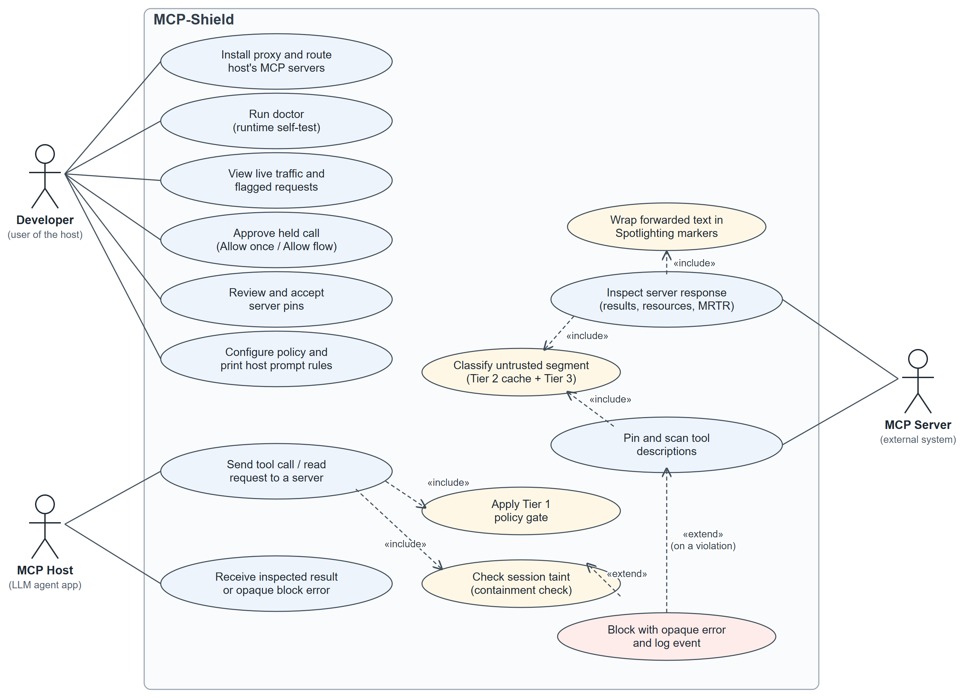
Figure 4: Use case diagram of MCP-Shield

4.2.2 Sequence Diagram
The sequence diagram (Figure 5) follows one request from a host that reads a GitHub issue and is then tricked into running a shell command.
- The host sends tools/call get_issue with the Mcp-Method and Mcp-Name headers. Tier 1 checks the allowlist, header ↔ body consistency, the schema and the argument policy.
- The proxy forwards the call to the MCP server.
- The server returns the issue body text. The extractor produces the untrusted segment; Tier 2 misses the cache and Tier 3 classifies it.
- If the verdict is indirect_injection, a SecurityInjectionError with class and probability is logged locally and shown in the dashboard, and the host receives only the opaque error -32000 "Request blocked by MCP-Shield policy (ref 7f3a92c1)". The server receives nothing.
- If the verdict is benign, or in the abstain band (which escalates the session to strict), a taint record is stored and the result is forwarded inside Spotlighting markers.
- Later the host calls run_shell with arguments that overlap the tainted text. The taint engine finds the overlap on an execute-class tool and logs a SecurityTaintViolationError.
- The host receives a new opaque error with a fresh reference, and the call is never forwarded to the server.
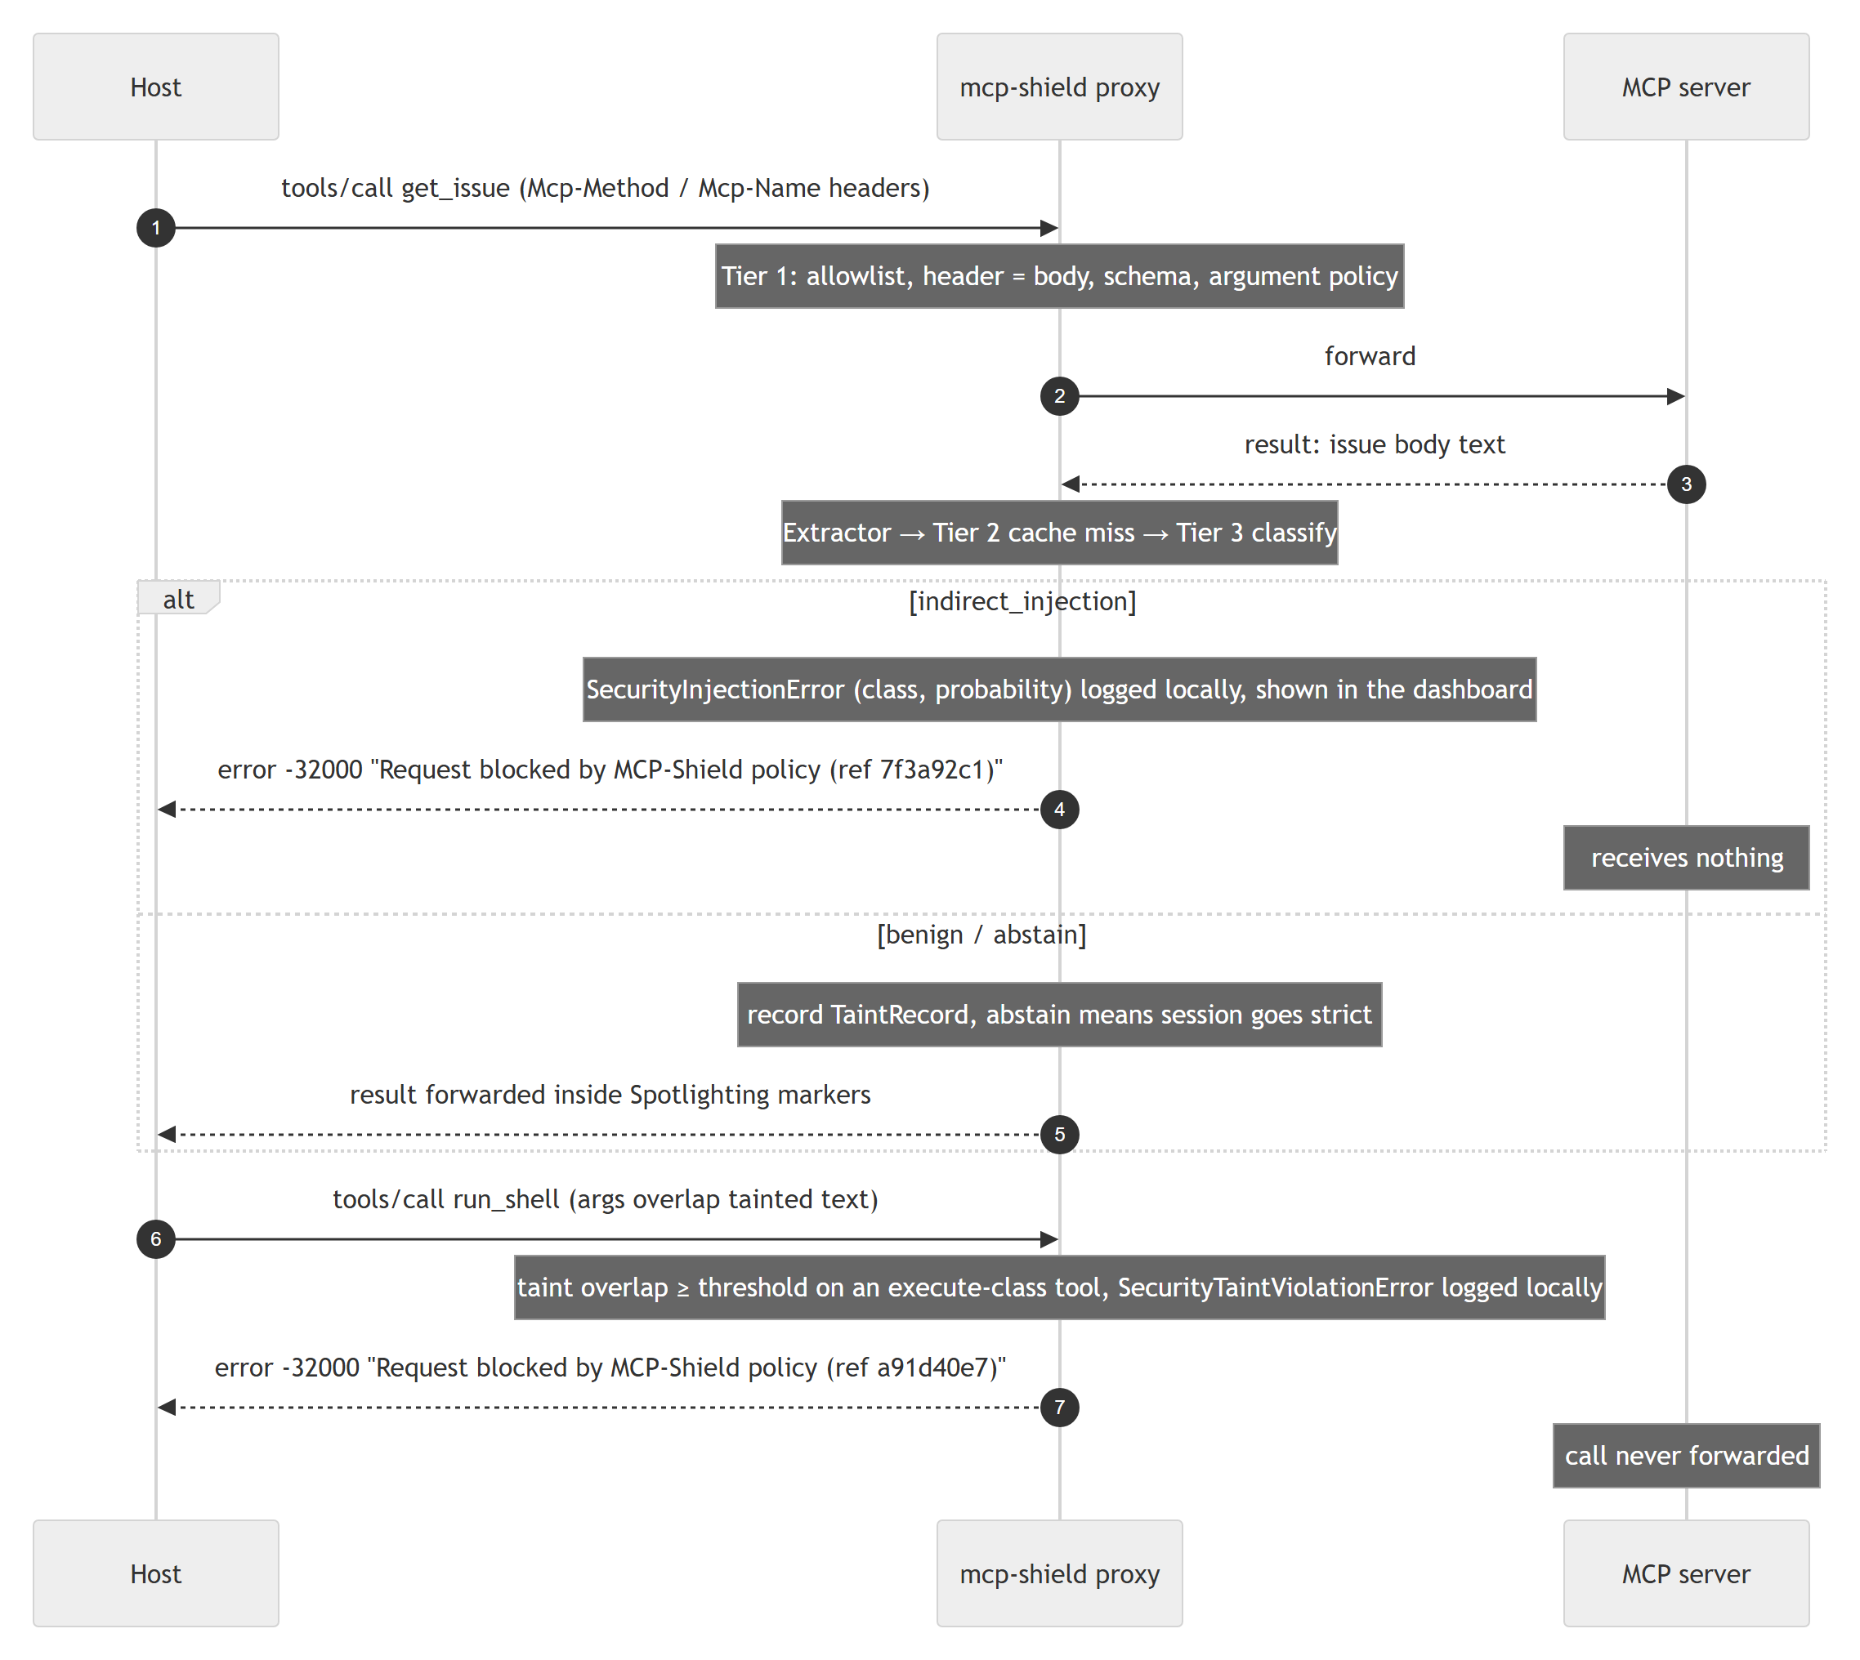
Figure 5: Sequence diagram — one request's path through the cascade, taint state and pin store

4.2.3 State Chart Diagram
Two pieces of MCP-Shield state change over time, and Figure 6 shows both.
(a) Server trust. A server seen for the first time, with no pin, enters Quarantined: only its read-class tools are exposed and its results are handled under strict policy. A server whose manifest matches a known manifest shipped with the package goes directly to Accepted. A developer accepting the pins moves a quarantined server to Accepted. If a later listing differs from the pin — a rug-pull or a legitimate update — the server moves to Changed, the changed tools are withheld and SecurityTamperingError is raised until the developer re-pins after viewing the diff and a clean re-scan. Probe detection (ten blocks in an hour) sends an accepted server back to Quarantined.
(b) Session taint policy. A host session starts Clean. When an untrusted result is forwarded it becomes Tainted, and overlapping write, execute, egress or cross-server calls are blocked. When every taint record has decayed (30 minutes) it returns to Clean. An abstain-band verdict, three blocks in ten minutes, or a result from a quarantined server moves it to Strict, as does taint_policy = "strict" in the configuration; in Strict every execute or egress call is held for Allow once and retry. Mark benign or Reset to standard in the dashboard returns it to Tainted.
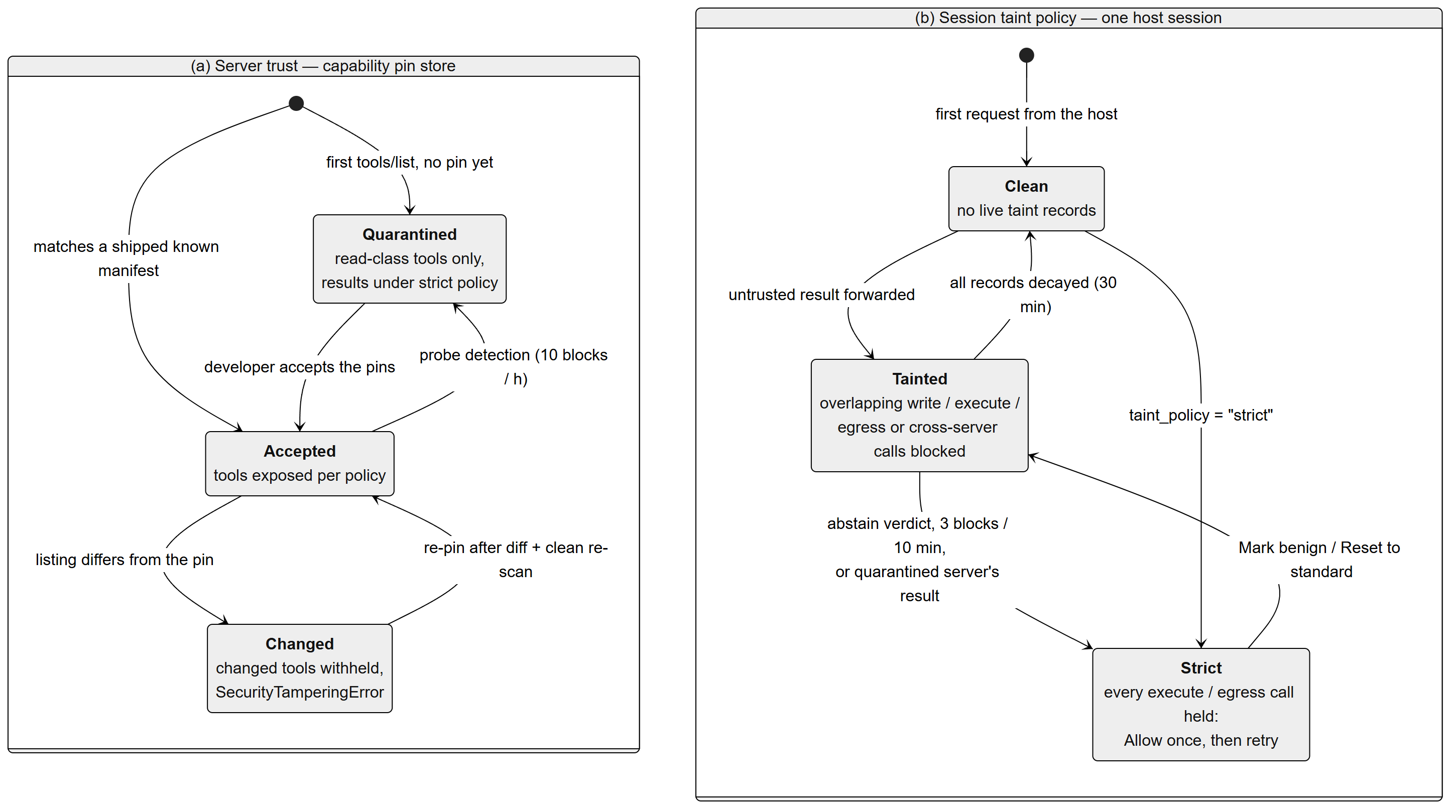
Figure 6: State chart diagram — (a) server trust and (b) session taint policy

4.2.4 Deployment Diagram
The deployment diagram (Figure 7) shows that everything runs on the developer's workstation. The MCP host application launches one mcp-shield proxy front-end per stdio server over stdio; each front-end spawns its MCP server as a child process and talks to the engine over a per-user local channel. The engine process contains the HTTP listener (127.0.0.1:8800), the local IPC server, the detection cascade, ONNX Runtime with the mcp-shield-clf.onnx artefact in the platform cache directory, the dashboard (127.0.0.1:8501), the SQLite store and mcp-shield.toml in the per-user data directory, and — only when HTTP entries are routed — a per-user login item (launchd agent, systemd user unit or Windows logon task).
Outside the workstation, the HTTP listener reaches remote Streamable HTTP servers over HTTPS, the classifier weights and model card are downloaded once from the Hugging Face Hub, and the package itself comes from PyPI. The optional Stage 2 llama-server runs as its own process on 127.0.0.1 and is called through an OpenAI-compatible API; it is never started by the engine.

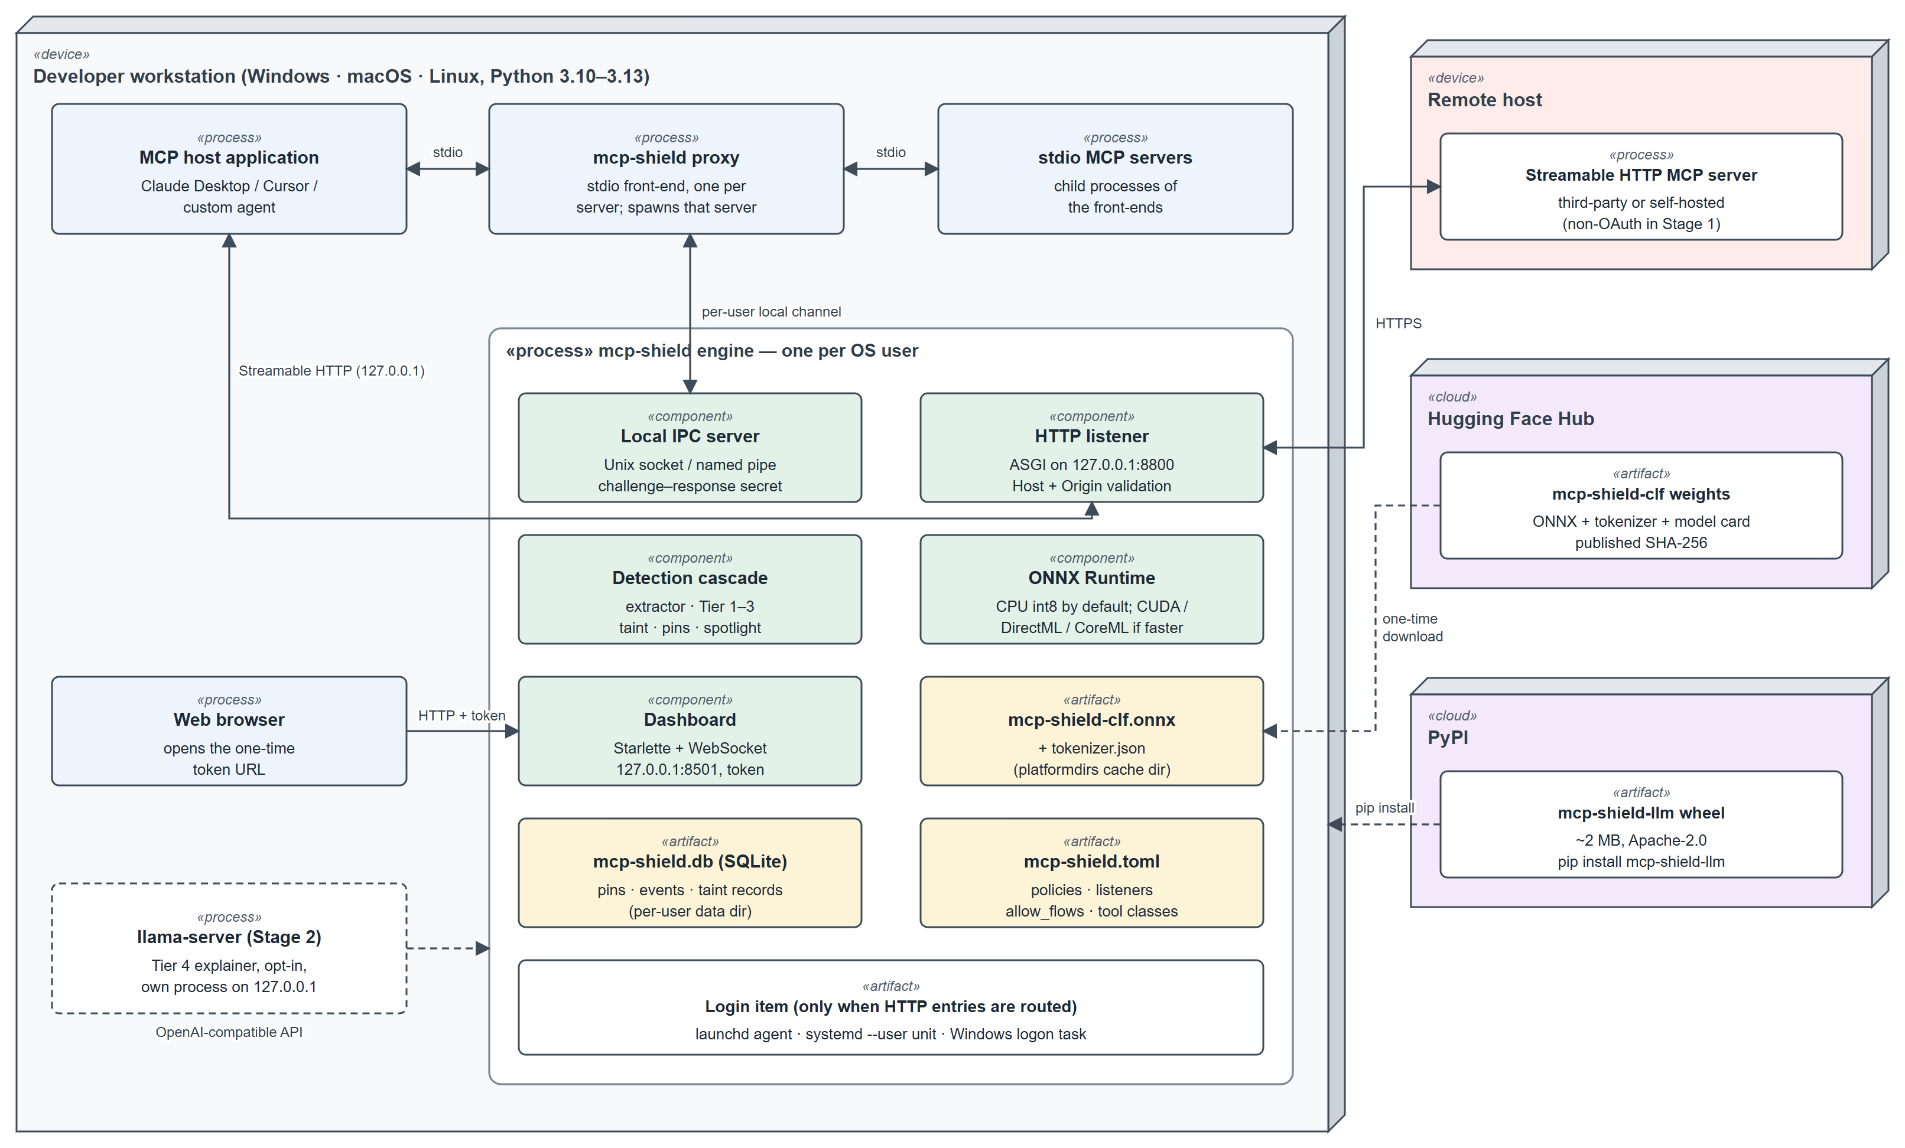
Figure 7: Deployment diagram of MCP-Shield

4.2.5 Class Diagram
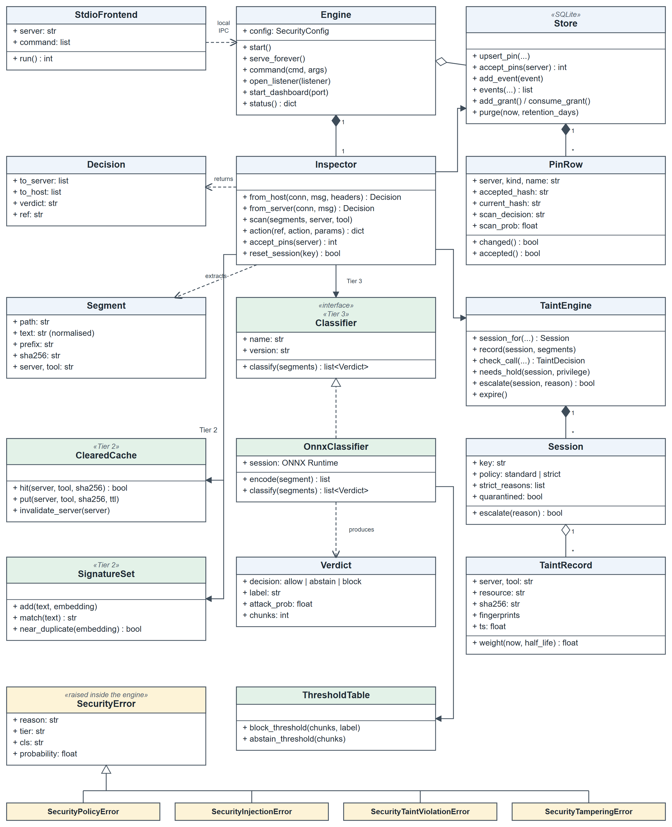
Figure 8: Class diagram of the MCP-Shield engine
The class diagram (Figure 8) shows the main classes of the Stage 1 implementation in the mcp_shield package. Engine owns one Inspector and aggregates the Store; StdioFrontend processes depend on the engine through the local IPC channel. The Inspector's from_host and from_server methods return a Decision (messages to forward to each side, the verdict and the reference ID); it extracts Segment objects and uses ClearedCache and SignatureSet (Tier 2), the Classifier interface (Tier 3), the TaintEngine and the Store.
OnnxClassifier realises the Classifier interface, uses a ThresholdTable for per-document block and abstain thresholds, and produces Verdict objects. The TaintEngine owns Session objects, each of which aggregates its TaintRecords; the Store owns the PinRows of the pin tables. The four security errors specialise SecurityError, which carries the reason, tier, class and probability inside the engine only.

4.3 Technologies Used
MCP-Shield combines a protocol proxy, a small transformer classifier and a local web dashboard. The following technologies are used.
Python and asyncio
Python is the implementation language of the package, the training pipeline and the tests. The engine and front-ends are built on asyncio, using the Proactor event loop on Windows (needed for named pipes and subprocess pipes) and uvloop on macOS and Linux when installed. Classifier inference runs in a worker thread so a CPU classification never stalls other traffic.
Model Context Protocol and JSON-RPC 2.0
MCP messages are JSON-RPC 2.0 objects carried over newline-delimited stdio or Streamable HTTP. MCP-Shield implements revision 2026-07-28 (stateless requests, routing headers, MRTR) and passes 2025-11-25 peers through during the deprecation window.
mDeBERTa-v3, Transformers and ONNX Runtime
The Tier 3 classifier is fine-tuned from microsoft/mdeberta-v3-base (MIT licence) with Hugging Face Transformers and Datasets, exported to ONNX, quantised to int8 for CPU (including the embedding table) and kept in fp16 for GPUs. ONNX Runtime serves it with the CPU, CUDA, DirectML or CoreML execution provider; the exported graph returns both the class logits and the pooled vector reused for near-duplicate rejection and taint embeddings, and ships with tokenizer.json, so the runtime needs neither PyTorch nor Transformers.
Dataset preparation and training
The training pool combines public attack corpora, synthetic MCP-shaped segments generated by an open-weight model with structured output (each attack paired with a minimal benign twin), captured benign tool traffic and hard negatives. Figure 9 shows the pipeline: global deduplication within each label, grouping by document, a grouped and stratified 80/10/10 split, augmentation on the training split only, fine-tuning with class-weighted cross-entropy, two to three adversarial rounds, calibration and ONNX export. Held-out suites never enter it. The minimum viable dataset is at least 20,000 segments from sources the team controls, with the class mix in Table 10.
Table 10: Training class mix
Class | Share of training pool | Notes
benign | ~85% | At least 25% hard negatives: security documents, shell commands in code-review output, innocent uses of "ignore" or "system prompt", benign imperative tool descriptions
indirect_injection | ~8% | Multilingual, multi-format: markdown, HTML comments, JSON strings, base64-wrapped
command_injection | ~4% | Shell operators, traversal, URL smuggling in arguments and result text
description_poisoning | ~3% | Tool descriptions, schema field descriptions, prompt templates

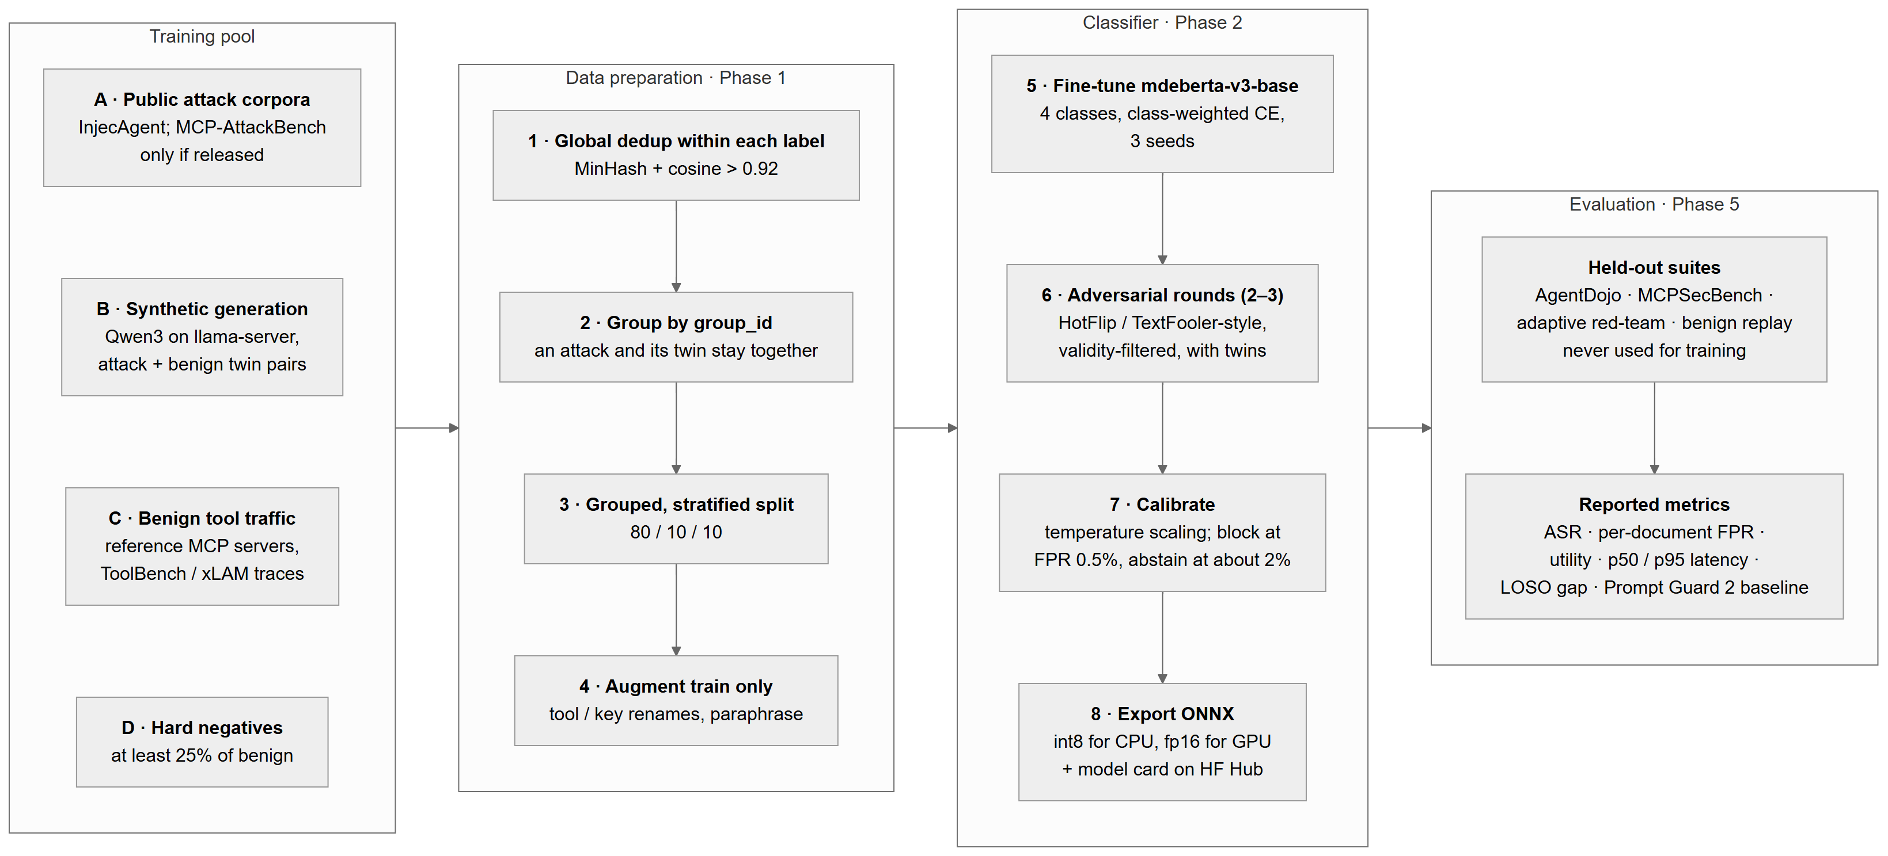
Figure 9: Dataset preparation, training and evaluation pipeline of the classifier
Starlette, Uvicorn, httpx and WebSocket
The Streamable HTTP listener is an ASGI application under Uvicorn inside the engine, using httpx to reach upstream servers. The dashboard is a Starlette application with a token-authenticated WebSocket feed for the live traffic log and a static HTML/JavaScript front-end.
SQLite
A SQLite database in the per-user data directory holds the pin tables, the event store behind the dashboard, taint records, probe counters and approval grants, so that a restarted engine keeps its security state.
Hugging Face Hub, huggingface_hub and platformdirs
The classifier weights and model card are hosted on the Hugging Face Hub (file storage only, not an inference API), downloaded once with huggingface_hub into the operating system's cache directory chosen by platformdirs, and verified against published SHA-256 values.
llama.cpp (Stage 2, data generation and benchmark agent)
llama.cpp's llama-server runs an open-weight 8B model (Qwen3-8B by default) as a GGUF file with an OpenAI-compatible API and JSON-schema-constrained output. It generates synthetic training data, acts as the reproducible agent under attack in the benchmarks, and in Stage 2 powers the optional explainer. It was chosen over a managed daemon so that the release, model file, quantisation, context size and sampling settings are all pinned by MCP-Shield.
pytest, GitHub Actions and PyPI
Unit, integration and end-to-end tests are written with pytest against fake MCP servers and a tiny test model. Continuous integration runs on Linux, Windows and macOS, and the 4-vCPU runner provides the canonical CPU-only latency baseline. The package is built with build and published to PyPI as mcp-shield-llm through Trusted Publishing, without long-lived tokens.
Docker, Kubernetes, OpenTelemetry and PyJWT (Stage 1E)
The enterprise basics add a Dockerfile, docker-compose file and Kubernetes sidecar manifest, export audit records through the OpenTelemetry SDK over OTLP with MCP trace-context propagation, and validate OAuth 2.1 bearer tokens with PyJWT against a JWKS endpoint.
Git
Git is used for version control of both the documentation vault and the code repository.

REFERENCES
[1] N. Maloyan and D. Namiot, "Breaking the Protocol: Security Analysis of the Model Context Protocol Specification and Prompt Injection Vulnerabilities in Tool-Integrated LLM Agents," arXiv:2601.17549, Jan. 2026.
[2] Y. Yang, D. Wu and Y. Chen, "MCPSecBench: A Systematic Security Benchmark and Playground for Testing Model Context Protocols," arXiv:2508.13220, 2025.
[3] Z. Wang et al., "MCP-Bench: Benchmarking Tool-Using LLM Agents with Complex Real-World Tasks via MCP Servers," arXiv:2508.20453, 2025.
[4] W. Xing, Z. Qi, Y. Qin, Y. Li, C. Chang, J. Yu, C. Lin, Z. Xie and M. Han, "MCP-Guard: A Multi-Stage Defense-in-Depth Framework for Securing Model Context Protocol in Agentic AI," arXiv:2508.10991, 2025.
[5] İ. A. Turgut and E. Gümüş, "CASCADE: A Component Ablation and Corpus Audit of a Layered Local Defense for MCP-Based Systems," arXiv:2604.17125, Apr. 2026.
[6] M. Rostamzadeh, S. Narula, N. Birhan, M. Ghasemigol and D. Takabi, "MCP-DPT: A Defense-Placement Taxonomy and Coverage Analysis for Model Context Protocol Security," arXiv:2604.07551, Apr. 2026.
[7] K. Greshake, S. Abdelnabi, S. Mishra, C. Endres, T. Holz and M. Fritz, "Not What You've Signed Up For: Compromising Real-World LLM-Integrated Applications with Indirect Prompt Injection," in Proc. ACM AISec, 2023. arXiv:2302.12173.
[8] Q. Zhan, Z. Liang, Z. Ying and D. Kang, "InjecAgent: Benchmarking Indirect Prompt Injections in Tool-Integrated LLM Agents," in Findings of ACL, 2024. arXiv:2403.02691.
[9] E. Debenedetti, J. Zhang, M. Balunović, L. Beurer-Kellner, M. Fischer and F. Tramèr, "AgentDojo: A Dynamic Environment to Evaluate Prompt Injection Attacks and Defenses for LLM Agents," in NeurIPS Datasets and Benchmarks, 2024. arXiv:2406.13352.
[10] E. Debenedetti, I. Shumailov, T. Fan, J. Hayes, N. Carlini, D. Fabian, C. Kern, C. Shi, A. Terzis and F. Tramèr, "Defeating Prompt Injections by Design," arXiv:2503.18813, 2025.
[11] K. Hines, G. Lopez, M. Hall, F. Zarfati, Y. Zunger and E. Kiciman, "Defending Against Indirect Prompt Injection Attacks With Spotlighting," arXiv:2403.14720, 2024.
[12] S. Chennabasappa, C. Nikolaidis, D. Song et al., "LlamaFirewall: An open source guardrail system for building secure AI agents," arXiv:2505.03574, May 2025.
[13] Meta, "Llama Prompt Guard 2" model card (meta-llama/Llama-Prompt-Guard-2-86M and -22M), Hugging Face, 2025.
[14] R. Bhagwatkar, K. Kasa, A. Puri, G. Huang, I. Rish, G. W. Taylor, K. D. Dvijotham and A. Lacoste, "Indirect Prompt Injections: Are Firewalls All You Need, or Stronger Benchmarks?" arXiv:2510.05244, 2025.
[15] M. Fomin et al., "When Benchmarks Lie: Evaluating Malicious Prompt Classifiers Under True Distribution Shift," arXiv:2602.14161, Feb. 2026.
[16] J. Fairoze, S. Garg, K. Lee et al., "Bypassing Prompt Guards in Production with Controlled-Release Prompting," arXiv:2510.01529, Oct. 2025.
[17] Z. Zhang et al., "Agent-SafetyBench: Evaluating the Safety of LLM Agents," arXiv:2412.14470, 2024.
[18] M. Lupinacci et al., "The Dark Side of LLMs: Agent-based Attacks for Complete Computer Takeover," arXiv:2507.06850, 2025.
[19] Model Context Protocol, Specification revision 2026-07-28, "Key Changes" changelog, modelcontextprotocol.io/specification/2026-07-28/changelog.
[20] Model Context Protocol, "Security Best Practices," modelcontextprotocol.io/specification/2026-07-28/basic/security_best_practices.
[21] Equixly, "MCP Servers: The New Security Nightmare," blog post, 29 Mar. 2025.
[22] HackerOne, "9th Annual Hacker-Powered Security Report," Oct. 2025.
[23] NIST National Vulnerability Database, CVE-2025-49596 — MCP Inspector unauthenticated localhost HTTP server.
[24] Invariant Labs, mcp-scan, GitHub repository, 2025.
[25] riseandignite, mcp-shield (static scanner of MCP server configurations; unrelated to this project), GitHub repository, 2025.
[26] Cisco AI Defense, mcp-scanner (PyPI: cisco-ai-mcp-scanner), GitHub repository, 2025.
[27] A. Madry, A. Makelov, L. Schmidt, D. Tsipras and A. Vladu, "Towards Deep Learning Models Resistant to Adversarial Attacks," in Proc. ICLR, 2018. arXiv:1706.06083.
[28] J. Ebrahimi, A. Rao, D. Lowd and D. Dou, "HotFlip: White-Box Adversarial Examples for Text Classification," in Proc. ACL, 2018. arXiv:1712.06751.
[29] D. Jin, Z. Jin, J. T. Zhou and P. Szolovits, "Is BERT Really Robust? A Strong Baseline for Natural Language Attack on Text Classification and Entailment," in Proc. AAAI, 2020. arXiv:1907.11932.
[30] S. Schleimer, D. S. Wilkerson and A. Aiken, "Winnowing: Local Algorithms for Document Fingerprinting," in Proc. ACM SIGMOD, 2003, pp. 76–85. doi:10.1145/872757.872770.

